

iSGTW Status Update
April, 2012
April 2012:

The story ‘The smallest music in the universe’ was picked up by Symmetry Magazine, Discovery News, Wired UK and Wired US. But, Wired UK put the wrong link in the story which meant we didn’t get as much website visitors as we should have. The story ‘Gamma waves, gravity waves and galactic GPS’ was also picked up by Symmetry Magazine. CERN also retweeted the story: ‘Is open hardware creating a more open world’, which drove a lot of traffic to our website and a lot of new followers on Twitter.

September 2011 to February 2012 Summary:

This report summarises the data collected over the past 6 months (September 2011 to February 2012) during project year 2 of e-ScienceTalk. It particularly focuses on social media activity, which has made a positive impact on our website traffic. I have collated all of the data into graphs to identify areas of decline and growth, and below provide recommendations of where we should continue to focus our efforts.

One interesting trend that we noticed was that brand recognition influences how long visitors stay on the site. For example, we noticed an interesting trend when looking at data for Q5 on Google Analytics data. It shows that when you search ‘iSGTW’ there were 897 visits with visitors viewing 4.16 pages per visit, and taking 4.16 minutes on site. There was also a very low bounce rate (38.02%).This suggests that if you are intentionally looking for content from iSGTW, you stay longer on the site.

Recommendations:

We should be consistent across all our social media reporting by comparing ourselves to HPC Wire and Datanami. This is because even though these publications are commercial, their news coverage is similar to iSGTW’s. They’re also international publications and cover emerging trends in big data, cutting-edge technologies and high-performance computing.

The social media tracking tools I will continue to use are Klout, TweetReach, Topsy, Twitter Tracker, Social Mention and Twiangulate. But, some tools such as Topsy do not let me retrospectively look back in time to analyse data from a few months ago. Zara Qadir is looking at a couple of dashboard options which should make things easier.

I will not report on sentiment anymore on Social Mention as this is a very arbitrary metric and I am sceptical about the methodology that Social Mention uses.

Tweeting 3 to 7 times a day on Twitter has helped increase our Twitter followers and website traffic to iSGTW. Using other social media tools such as Facebook, StumbleUpon, Reddit and Slashdot to promote iSGTW stories has also driven more website traffic. Also, using automated tools such as IFTTT and future tweeting has been useful in increasing the volume and reach of our stories online.

I will setup email alerts for all the social media tools that I use for myself and Zara Qadir, to help us reduce the manual effort of extracting data from them all.

I will start including tallies of comments on iSGTW articles as engagement and interactivity are important indicators of impact, with over 65.5% stating that retweets, comments, likes, upload videos etc. are top of mind when it comes to measuring social success.

One suggestion would be to get access to Google Analytic’s social engagement section for our social bookmarking and sharing impact. The reasons for this recommendation is that we use Google Analytics heavily for website reporting, so it makes sense to apply this approach by using the same tool to track our social media impact. Also, many of the independent social media tools mentioned above may disappear, which happens frequently. To incorporate the social engagement tool into Google Analytics we would need to configure iSGTW’s Drupal plugin by including Google Analytics AddThis code.

We should identify ways to collect ideas about the content of iSGTW’s most popular stories. From this, we would be able to make statements such as what our audience likes or dislikes, and tailor our content accordingly. Collecting information about the research topics of all our stories per month has provided some qualitative data, but an effective way to analyse this data is not apparent yet.

The e_Science Talk team will try to develop a monthly feedback loop, examining what stories sparked off the most amount of interactions, page views etc.

We should think about how to use our social media tools to increase our newsletter subscribers, such as working with HPC Wire to cross-promote our audiences.

Email newsletter subscribers:
(Subscriber data since April 2005. Data from Drupal: Open Publish CMS and previous
iSGTW CMS.)
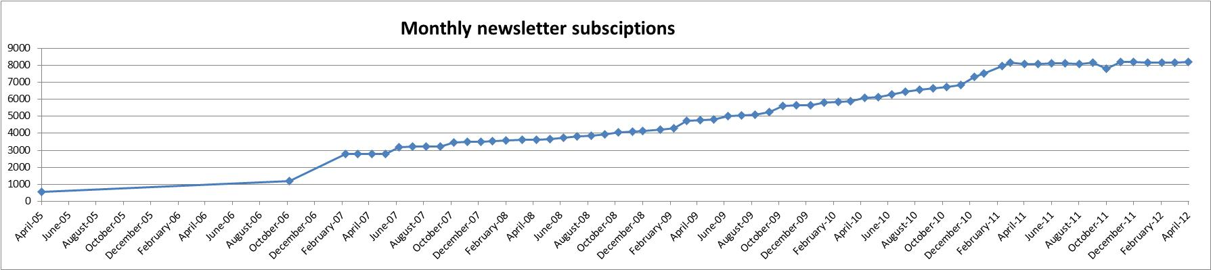

Email newsletter subscribers in project year 2:
Since October 2011 the average click-through-rate (CTR) from email newsletter to iSGTW homepage has been falling. This percentage is proportional with the number of newsletter subscribers that are also falling. But, in November 2011, we saw a spike of 401 new email subscribers from the previous month, added from the SciTech Europe list.

In April 2012, monthly subscribers increased from the previous month by 26 and the average CTR remained the same.

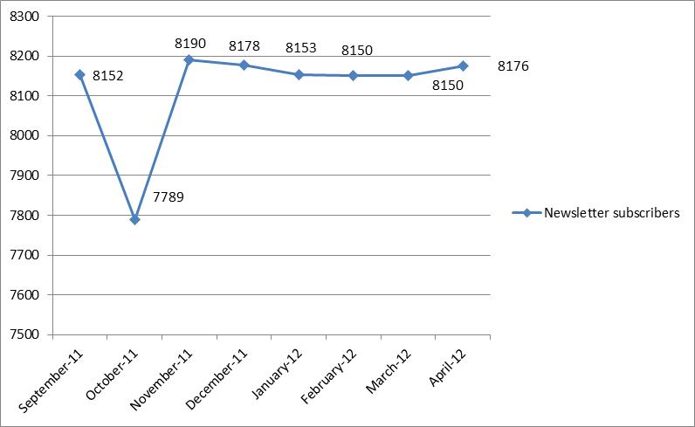
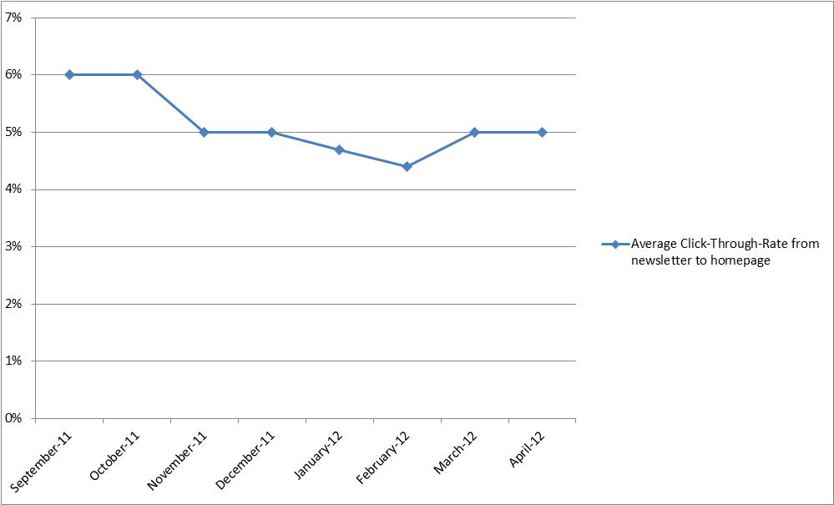

All iSGTW newsletter subscribers and social media followers:
Since year 2 of the project began in September 2011, iSGTW has received a total of 9,560 newsletter subscribers and followers on Twitter and Facebook. The largest growth we’ve seen is in our Twitter followers, which has increased by an average of 79 followers per month. This is because of active daily promotion by the team. On the other hand, we’ve noticed a slight fall in email newsletter subscribers, apart from November 2011 where there was a rise. The fall probably signifies users unsubscribing from our newsletter.

There is a growing trend for readers to consume media differently and through different channels. We should find out whether our subscribers are signing up to multiple channels, e.g. iSGTW’s Twitter, Facebook, etc.

In April, Facebook followers are up, but by a small amount. Twitter has seen the largest increase in followers as we passed the 1,000 follower barrier.

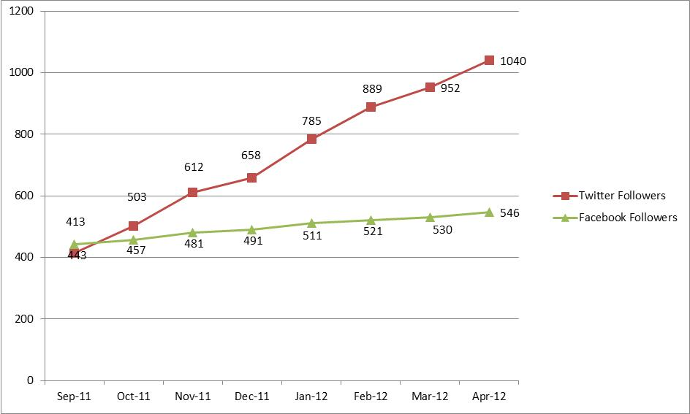

When comparing iSGTW website traffic with the year before we started our social media activity on 1st April 2011, there are some noticeable improvements. Since using social media, page views are up by 20% and average time spent on page is up by 54 seconds compared to last year. Our bounce rate has increased slightly by 2%. Using social media to promote iSGTW stories is particularly useful during the winter holiday and holiday period when online traffic typically falls. We used Twitter and other social media tools to publish during the 2011 winter holiday period which helped increase our website traffic.

April 2012 website statistics:

Page Views:
29,127

Visits:
18,823

Average Visit Duration:
01 minute 43 seconds

Bounce Rate:
68.29%

Top ten stories were:

- Is open hardware creating an open world? - 1,954 page views
- The smallest music in the universe – 1,840 page views
- Research Report - Turning the microscope inwards: Studying scientific software ecosystems – 762 page views - This is a feature from 2010 and had received a lot of page views in the last 2 months.
- Does computation threaten the scientific method? - 735 page views
- Museum brings prehistoric animals back to life – 569 page views
- Profile: Domenico Vicinanza Master of Fusion – 395 page views - This is a feature from 2011 and was popular because it was linked to by a Wired UK story.
- Open Software for Open Science – 339 page views
- Towards a collaborative data infrastructure for science – 308 page views
- Gamma rays, gravity waves and galactic GPS – 285 page views.
- Dear NASA: no more rainbows please – 285 page views.

Graph of website traffic this month by week:
April 2012:

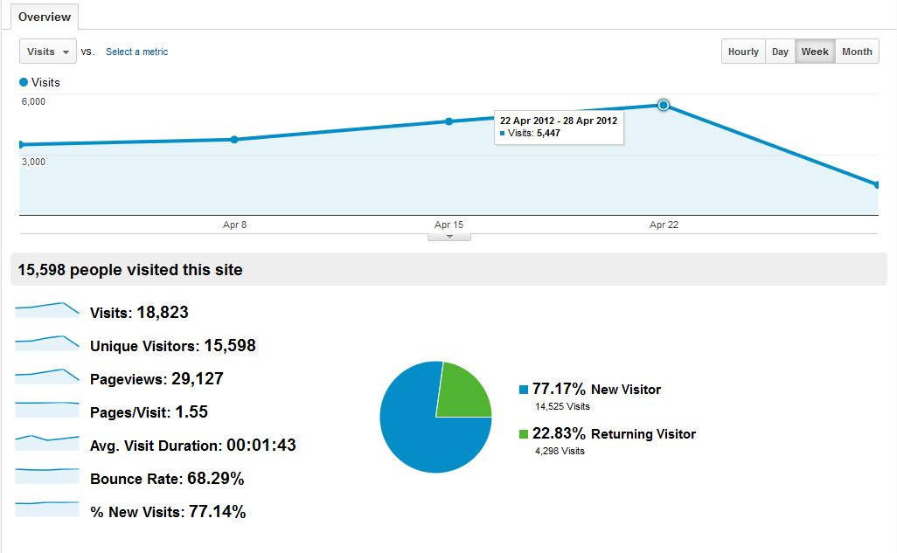

April 2011 – April 2012:
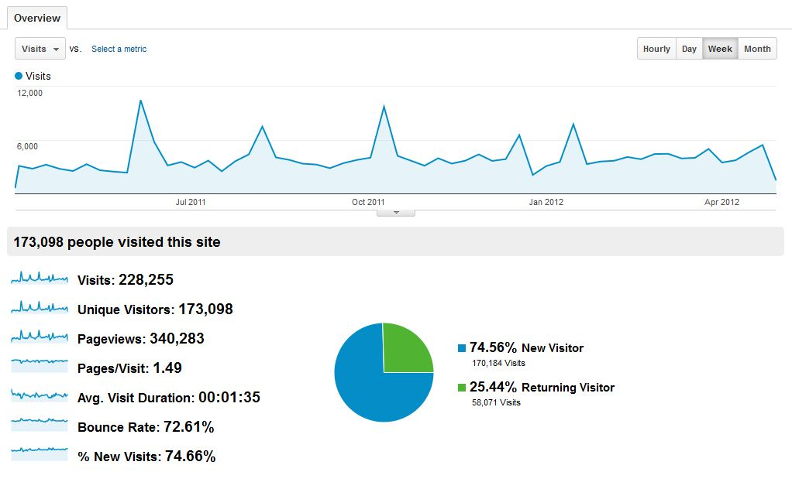

iSGTW website users:
Since the start of year 2, we’ve seen 56 new user accounts opened on iSGTW. On average, 19 users per month have accessed their accounts.

In April, the number of user accounts is still increasing, while the active users continue to decrease.

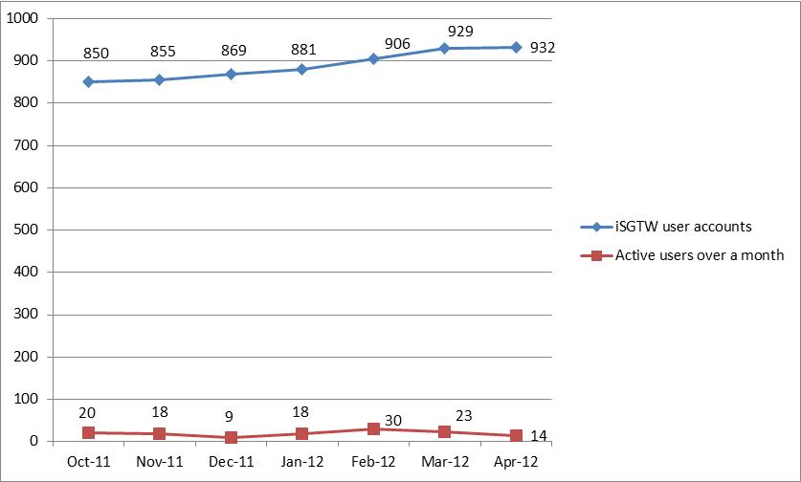

Twitter reach:

Data from Tweetreach.com. (Each date within the report, e.g. 11th November covers 7 to 8
days of activity. The dates below reflect data pulled at different times of the week and the lowest and highest reach activity we had per month.) The y axis denotes no. of tweets, people reached and impressions on Twitter. Tweetreach.com recorded an average of 36 to 50 per week from iSGTW since November 2011. Some of the lowest reach we had occurred on the 9th December 2011 and the 23rd January 2012. We had a large spike in the week around 12th January 2012. This was mainly due to a tweeter named @tw_top_science, which algorithmically selects which tweets to retweet. It picked up on our story ‘Happy 10th Birthday, WLCG!’.

In April, not much data was gathered because staff were away during the reporting periods so there are a few data gaps during the month. There is no way of retrieving data from this tool retrospectively. Plus, you can only pull data manually, which is another drawback.

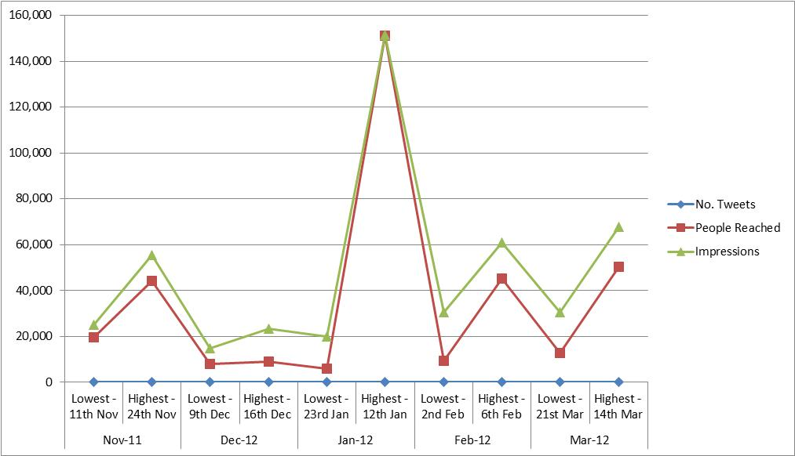

Commonality between iSGTW followers:
Using a tool called Twiangulate, it shows iSGTW, Datanami and HPC Wire have 40 followers in common who actively follow all publications, 165 people follow HPC Wire and iSGTW, 126 follow Datanami and HPC Wire, and 11 follow Datanami and iSGTW. The top 3 Twitter users with the most followers following us are Ideas Gate, NVIDIA Tesla, and HPC Guru. Currently iSGTW does not follow Ideas Gate or NVIDIA Tesla. It is important to have this level of knowledge so we can develop relationships with these individuals.

In April 2012, iSGTW, HPC Wire and Symmetry Magazine still had the same 4 influential followers in common from the previous month. These were Ideas Gate, astroparticle, Fermilab Today and NCAR+UCAR Science. All publications also had an increase in the total number of followers from 238 last month to 252 this month.

April 2012:

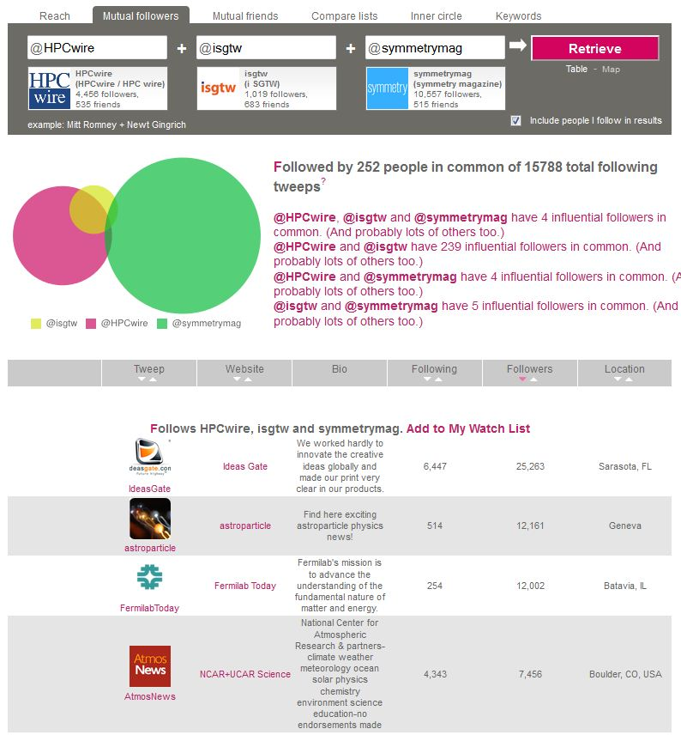

March 2012:
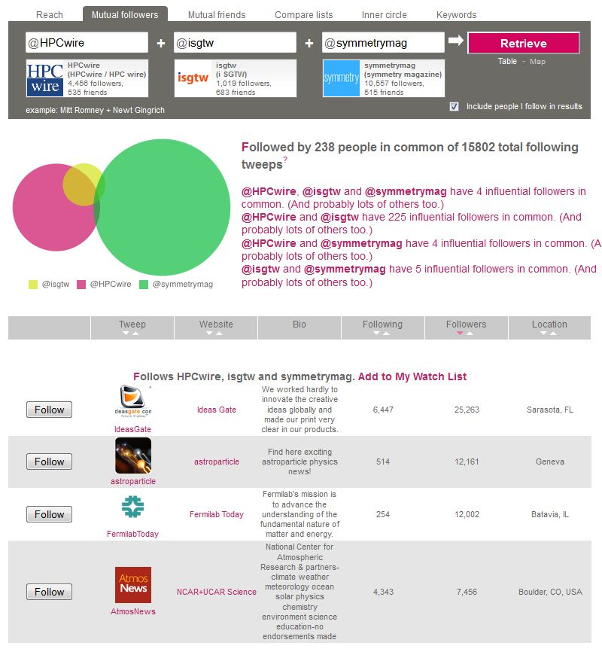

February 2012:
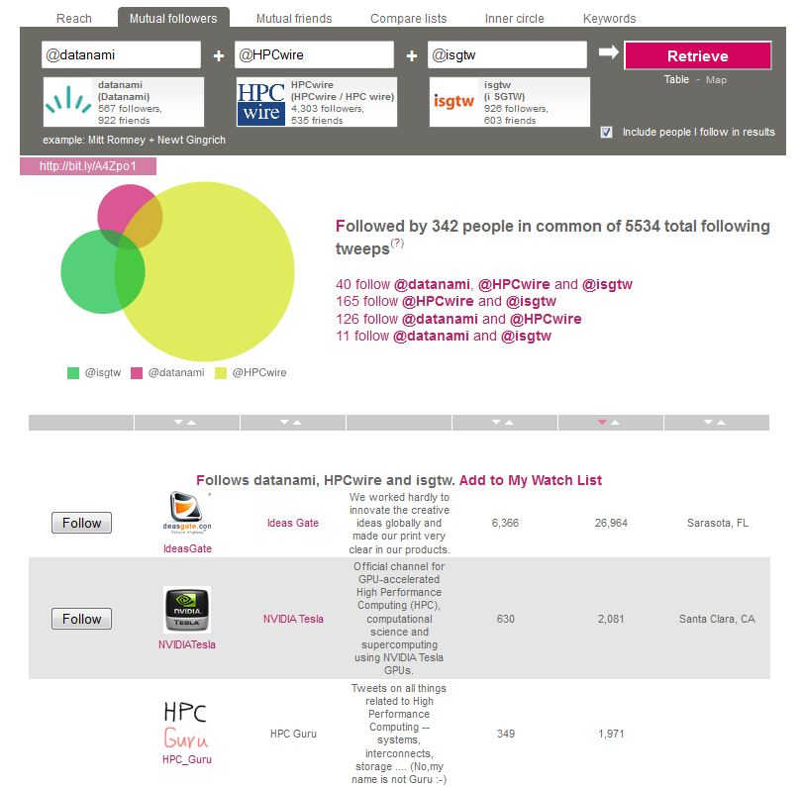

Mentions of iSGTW on Twitter
(Data is from Topsy.com.) During the past 5 months iSGTW stories that received the most mentions on Twitter by people were ‘Accelerate physics with your own computer’, ‘Following the 'red brick road' to data management’, ‘The forecast: no fire for tomorrow’, ‘A new take on simulating planet formation’ and ‘Seven innovative ways to cool a scientific computer’.

We also compared iSGTW with HPC Wire in February 2012. Even though HPC Wire has over 4 times our followers, they only tweet 2 to 3 times per day. iSGTW tweets around 3 to 7 times per day. There were 9 times during February that mentions by other twitter users of iSGTW stories equalled or surpassed HPC Wire’s.

April 2012:
This month, the top mentions (traffic spikes) were for the stories ‘Gamma Rays, Gravity Waves and Galactic GPS’ and ‘Is open hardware creating a more open world?’ One of these surpassed both our competitors on 2 May 2012.

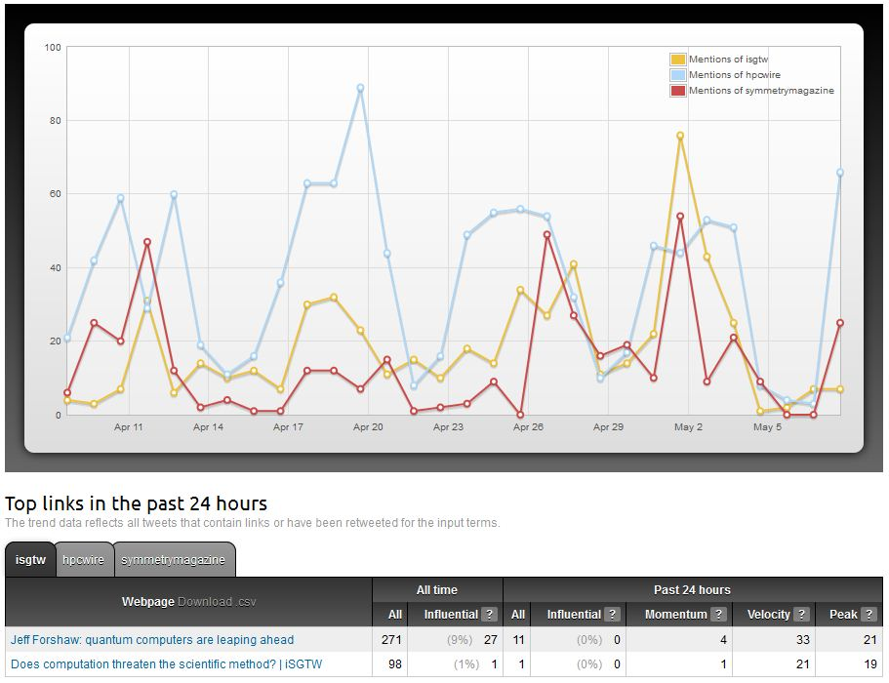

March 2012:
For iSGTW, the top story of the month was ‘Does scientific computation threaten the scientific method’, which surpassed mentions of both HPC Wire and Symmetry Magazine stories during the same period.
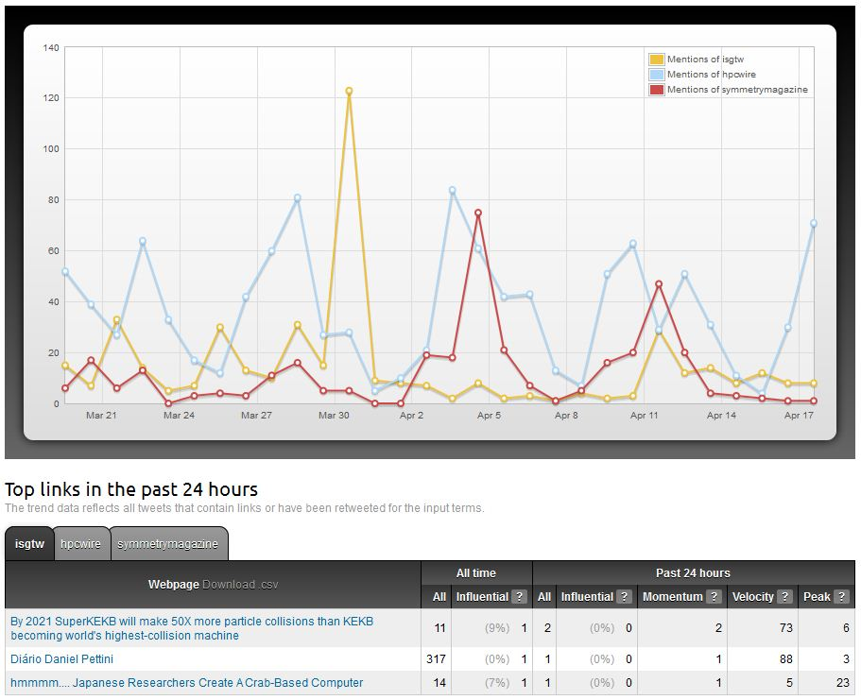

February 2012
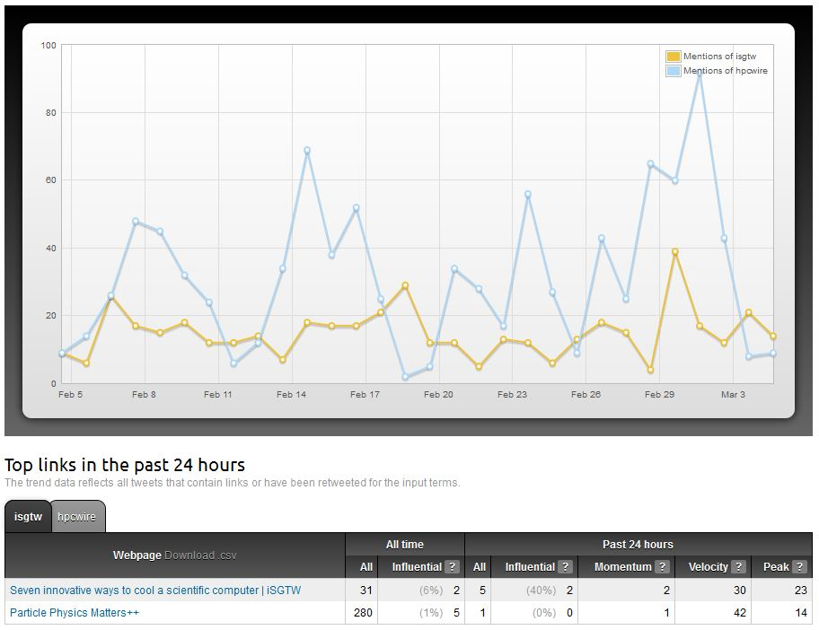

January 2012
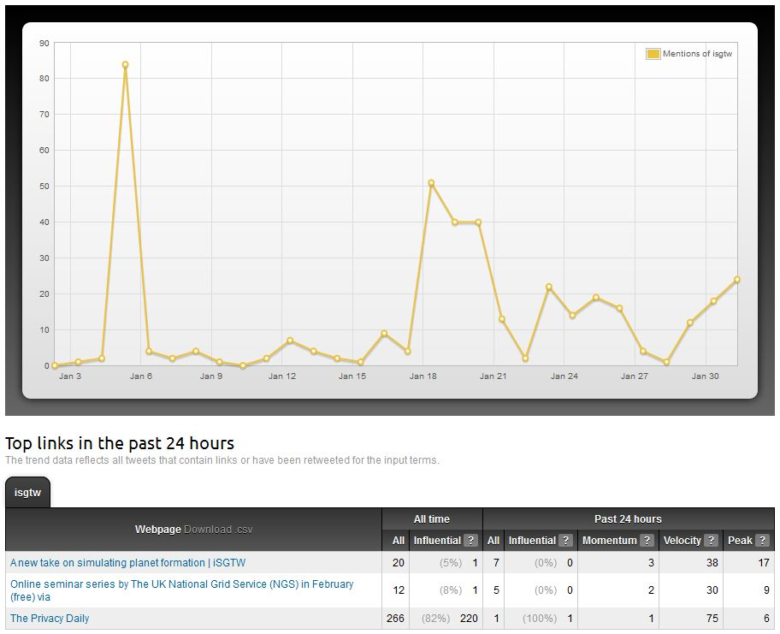

December 2011
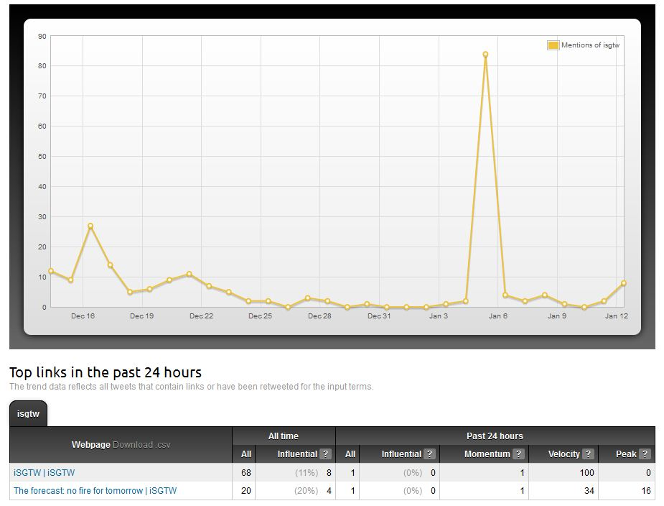

November 2011
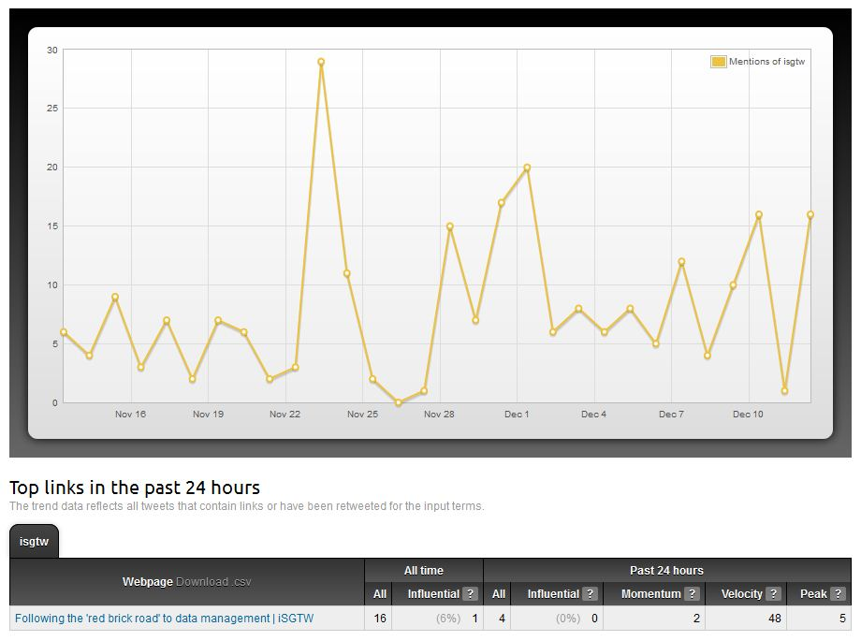

October 2011
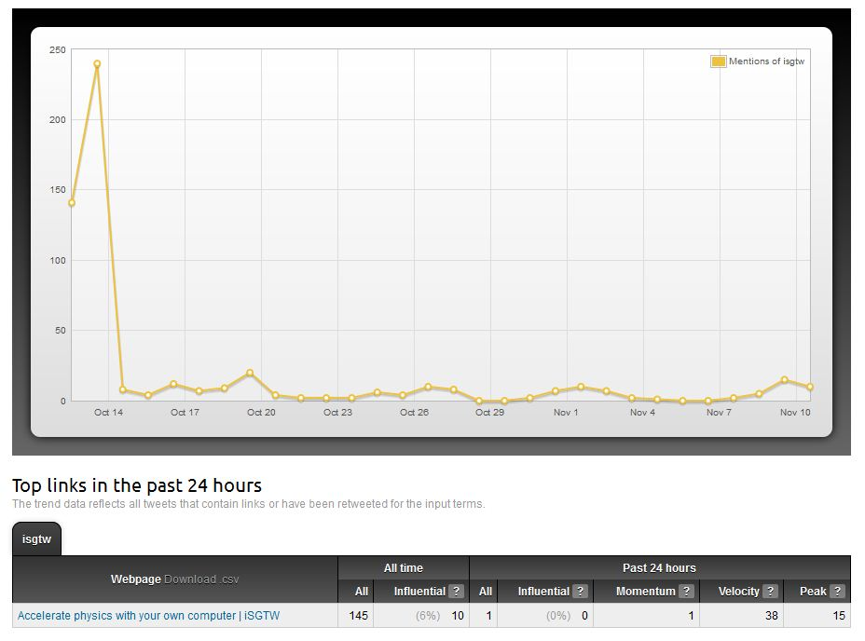

Since January 2012, we have used Twitter Tracker to compare iSGTW twitter followers with e-ScienceTalk and HPC Wire. On average, we received 3 new followers per day, compared with e-ScienceTalk’s 4 and HPC Wire’s 5. On occasion iSGTW followers surpassed both websites, especially if we had a popular tweet on a specific day.

In April 2012, average new followers ranged from 1 to 5 per day.

April 2012

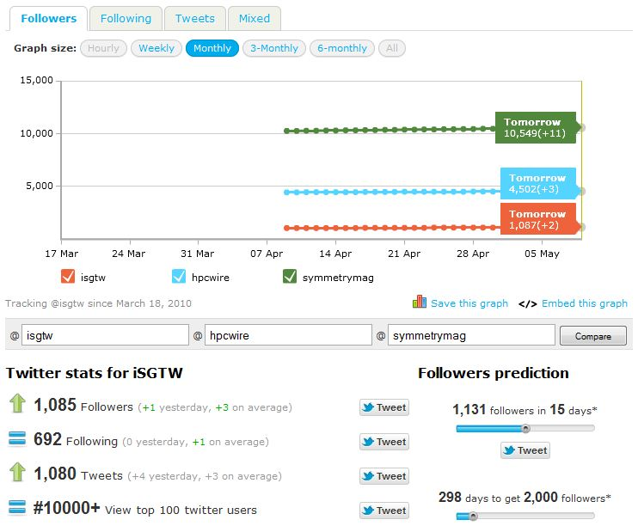

March 2012
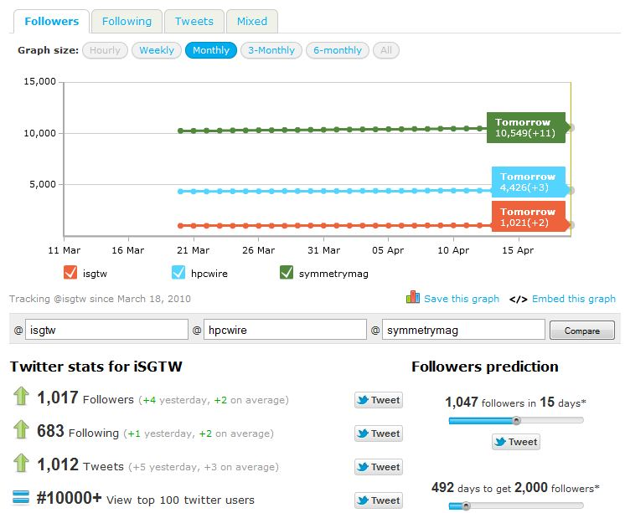

February 2012
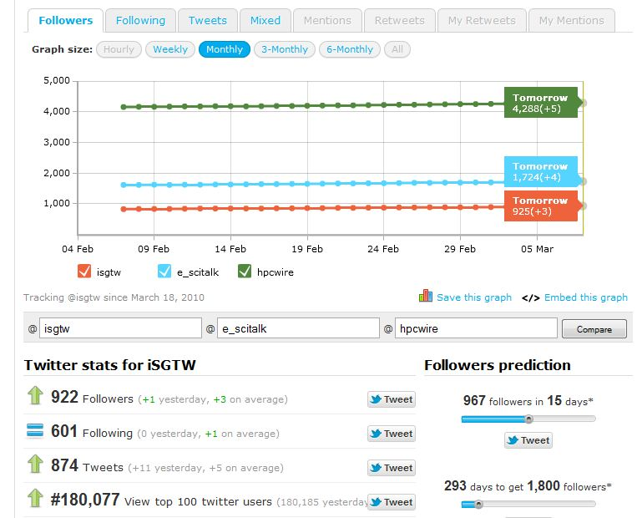

January 2012
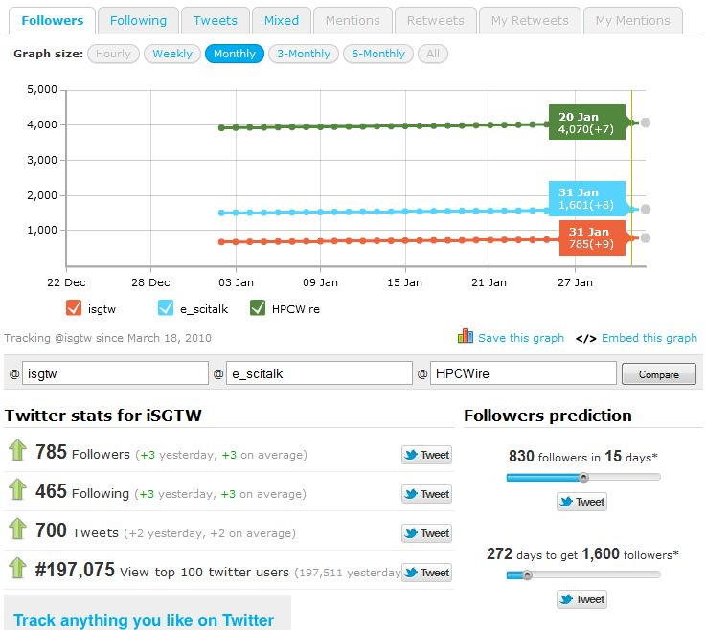

Interactivity:
Website traffic
(Data from Google Analytics)
Monthly page views and unique visitors have risen 3 out of 5 times during project year 2. The spike in October 2011 was mostly because of the story ‘Accelerate physics with your own computer’. Our website stickiness has fluctuated from 2.0 to 1.64 over 6 months. It’s currently at 1.89. Our bounce rate has also fluctuated between 65% and 76%. It’s currently at 69%. The number of countries that visitors have come from has fluctuated from 151 to 137.

In April 2012, monthly page views, unique visitors and number of countries visiting the site are down slightly. But, website stickiness has actually gone up. Our bounce rate is down which is also good.

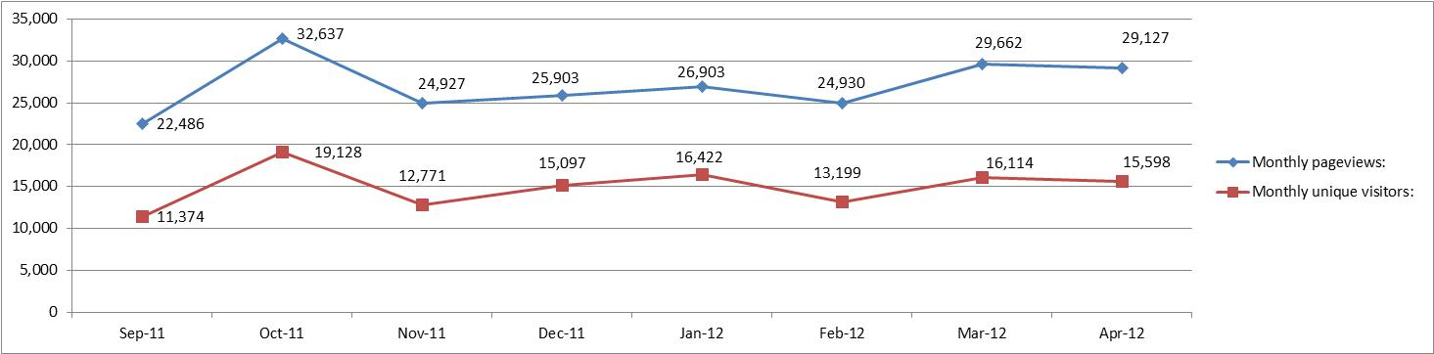

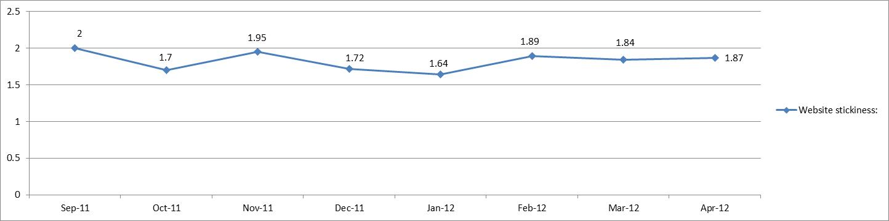

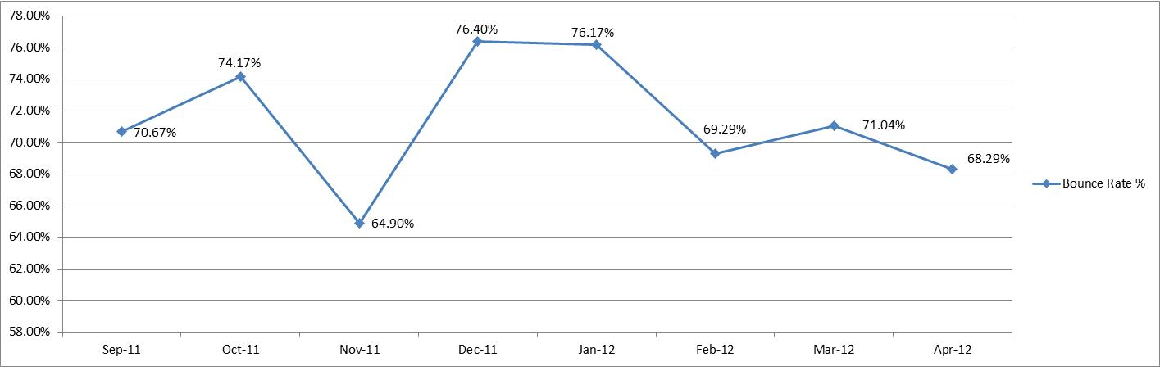

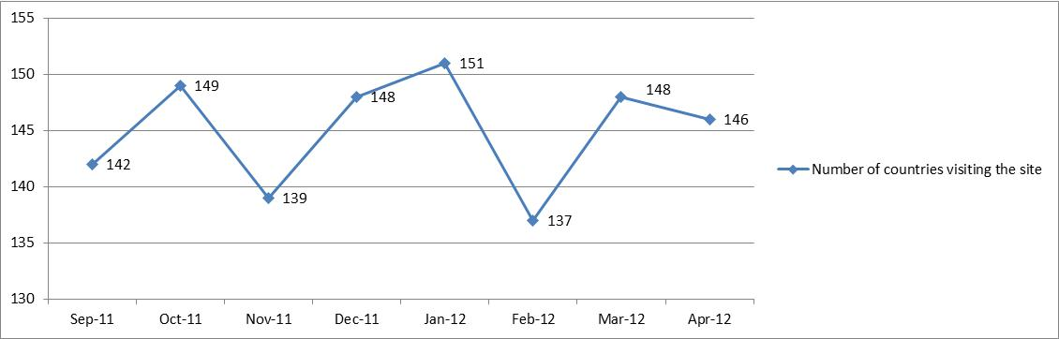

Over the past 6 months Google and direct traffic (probably from our newsletter) have been the top website traffic drivers to the iSGTW homepage. The top 3 to 5 social media sources fluctuate among StumbleUpon, Twitter, Facebook, Slashdot, Google Referrals, Reddit and BOINC.

In April 2012, the only change in traffic drivers was that the website lwn.net, a news and information source for the free software community, replaced Twitter as the 3rd most influential traffic driver.

Top 5 Traffic sources:

Over the past few years the top search keywords driving traffic via Google have included keywords relating to older articles from 2010 such as “santander” or “return of the hunters”. It appears that February 2012 is the first month that the top 5 keywords to iSGTW relate to articles we’ve covered recently in the past few months.

In April 2012, the keyword ‘software logos’ was a high traffic driver. This may be due to people searching for logos of open software and coming across out open hardware story.

Top 5 search and keyword phrases:

Other marketing/resources:

Total projects in the iSGTW resources section: 64
Added this month: 0
Total number added year to date: 64

iSGTW printed materials distributed this month: 0
Total number distributed: 610

Content

Number of issues published: 4
4th April 2012 - http://www.isgtw.org/issues/4-april-2012
11th April 2012 - http://www.isgtw.org/issues/11-april-2012
18th April 2012 - http://www.isgtw.org/issues/18-april-2012
25th April 2012 - http://www.isgtw.org/issues/25-april-2012

Top iSGTW stories on Google Analytics:
The y axis represents the no. of page views. Below are the most and least popular iSGTW stories over 6 months. The least and most popular stories were chosen from a selection of the top 10 stories, with 1 being highest and 10 being the lowest. Over the past 6 months the highest traffic peaks occurred for 3 stories. First was ‘Accelerate physics with your own computer’ in October 2011. Apart from organic Google traffic and direct to our site, the top traffic drivers were Twitter and StumbleUpon. Second was ‘The Tevatron's enduring computing legacy’ in December. Slashdot and Google referrals were the top traffic drivers. Third was ‘The Royal Society opens up permanently’ in January 2012. Reddit and Twitter were the top drivers. These traffic peaks represent 3 of the 4 highest spikes we’ve ever had since tracking started back in 2006. It’s interesting to note that even though the Tevatron story was popular, visitors did not stay long on the page (6.40 minutes) compared to the other top 2 stories.

In April 2012, the story ‘Is open hardware creating a more open world’ became the 4th most popular story in the last 7 months. It also became the 3rd top story within the last 7 months that visitors spent the most time on.

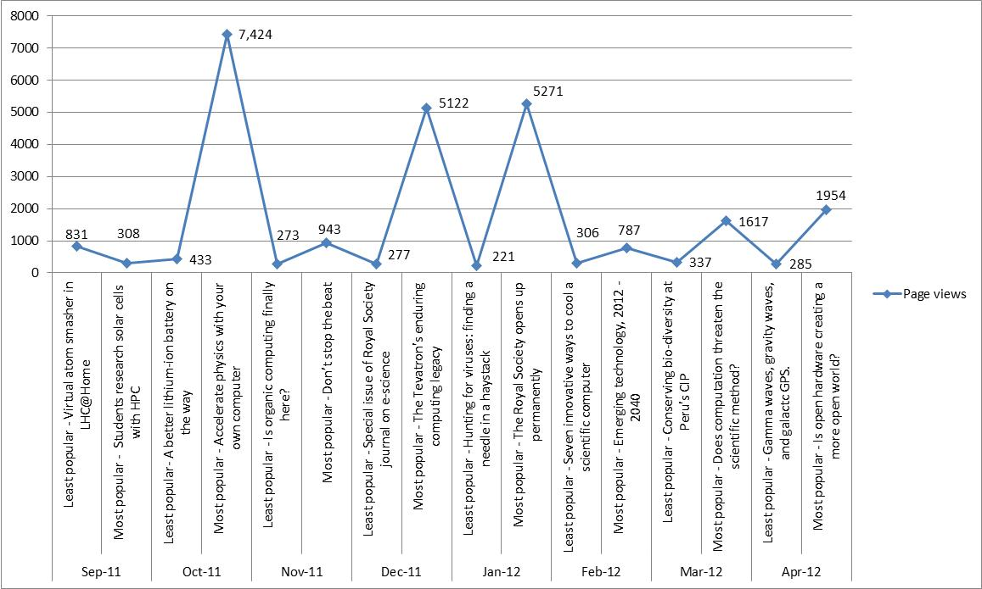

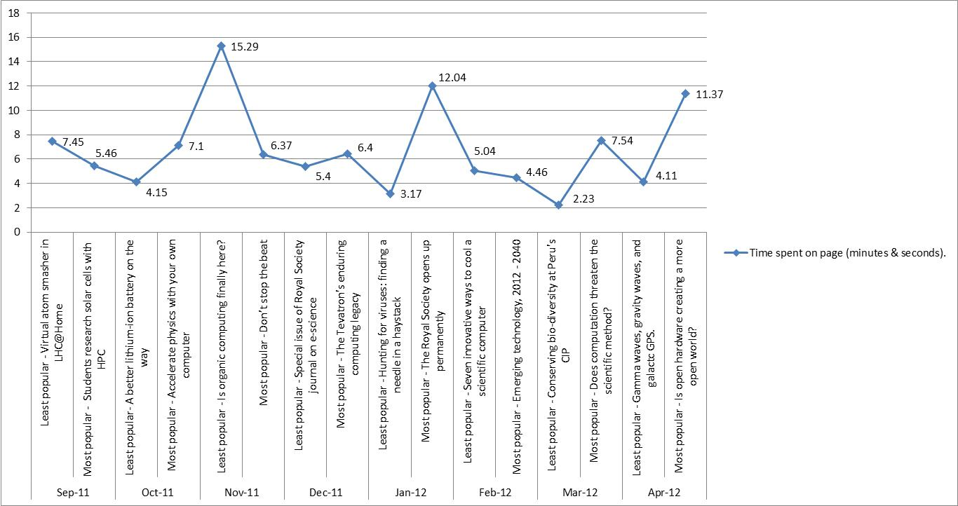

Number of mentions of computing areas in iSGTW stories:
Over 6 months, HPC is mentioned the most in 4 months out of 6. In February, it was mentioned 13 times in iSGTW stories. Desktop grids are only mentioned once during this whole time period in September 2011. Policy is also mentioned rarely.

In April 2012, HPC dropped from the top spot of mentions and general computing and other infrastructures took the top spot. Networks increased in mentions too. Other general topics that were mentioned include data, modelling and open-source hardware.

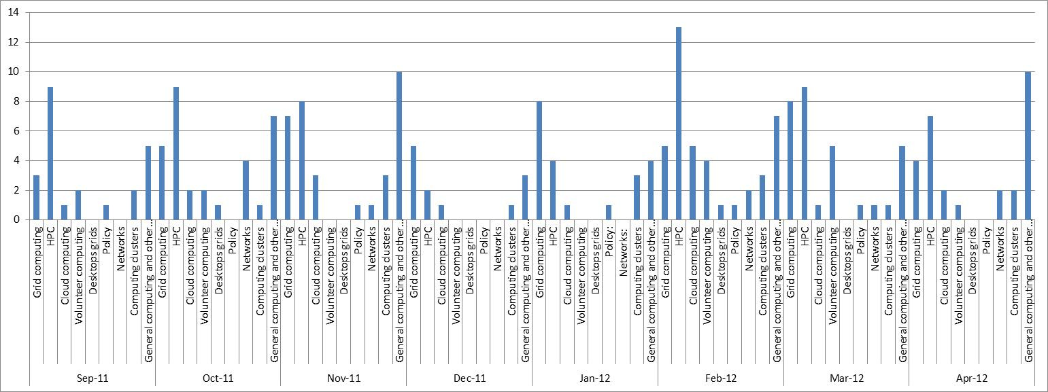

Geographic coverage of iSGTW stories:
The coverage between EU and US stories over 6 months is slightly biased towards the US in 5 out of the 6 months. South America is never mentioned. Africa and Asia-Pacific also receive very little coverage compared to the EU and US.

In April 2012, the US remains to most mentioned geographic area in iSGTW stories. Africa received a small mention also.
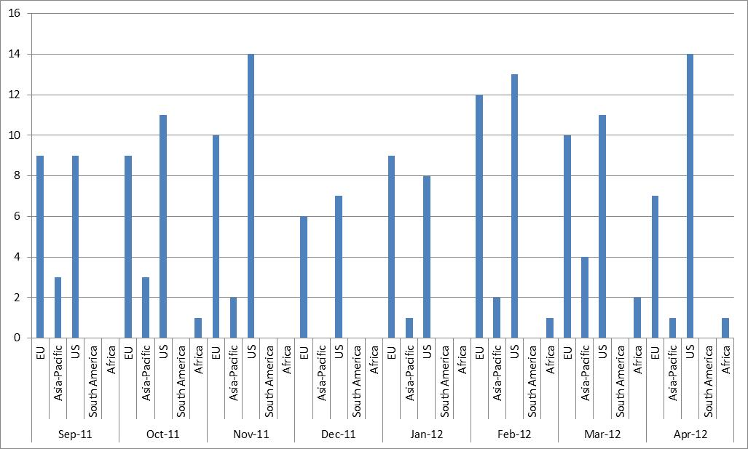

Klout score:
Klout looks at how influential you are. We had a spike in our Klout score on October 2011, which jumped from 34 to 52. This was mainly because of CERN retweeting one of our stories. Klout has various metrics you can look at. I need to identify which ones are the most useful and possibly make comparisons with our competitors.

In April 2012, our Klout score went up by 1 to 44.

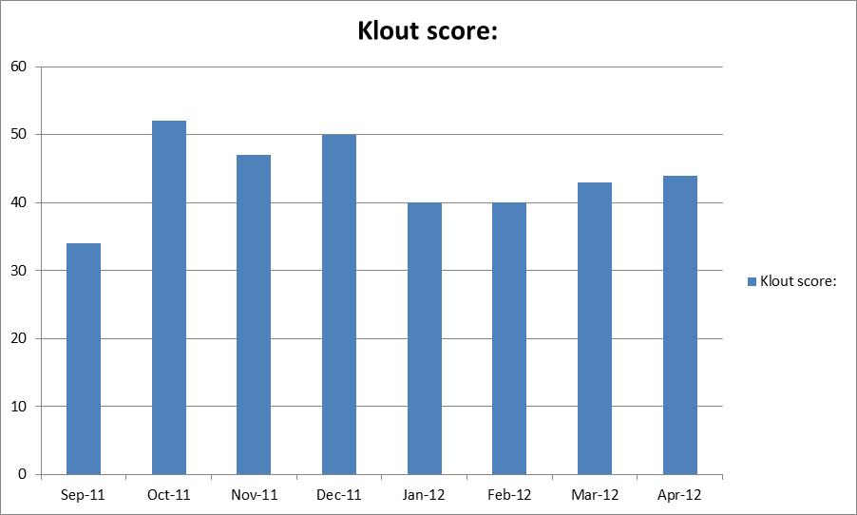

News:
- Hosting update:
DNS is owned by CERN, Bob is looking at how to move this.
- Board meeting:
No date set as funding issues have to be resolved.
- iSGTW funding: Letter of support with the EC for approval.

- Asia Pacific,editor, PRACE, XSEDE:
Lots of work at the moment for the editor.
AG helping with social networking for Weibo.

- The story ‘The smallest music in the universe’ was picked up by Symmetry Magazine, Discovery News, Wired UK and Wired US. In total, this story was tweeted to 1.5 million people. It received 66 direct retweets,

- The story ‘Gamma waves, gravity waves and galactic GPS’ was also picked up by Symmetry Magazine.

- CERN also retweeted the story ‘Is open hardware creating a more open world’ which drove a lot of traffic to our website.

- Adrian attended Global INET press event and spoke to Vint Cerf & Leonard Kleinrock – they’re interested in doing an opinion piece for iSGTW.

Social Media:
(Data is from Social Mention. What I’ve found is different results appear if you put in the brand URL instead of the brand name, or a space between names in the Social Mention tool search box. In the following graphs, data is missing for Scientific Computing, Computing Now and Supercomputing Online in October 2011 because I didn’t have that information then.

‘Strength’: The likelihood that our brand is being talked about in social media. A very simple calculation is used – phrase mentions within the last 24 hours divided by total possible mentions.

iSGTW equalled HPC Wire and Scientific Computing in November 2011. From January 2012, we have continued to surpass HPC Wire and Supercomputing Online as we continue to rise in strength.

In April 2012, HPC Wire continued to grow in social media strength. iSGTW and Supercomputing Online fell slightly.

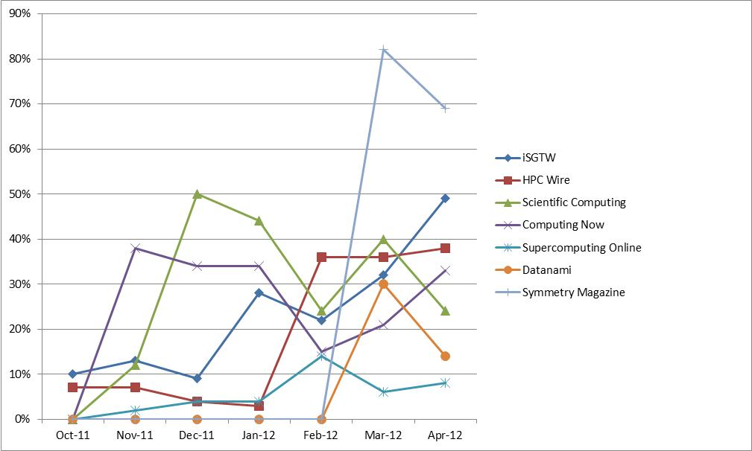

‘Sentiment’: The ratio of mentions generally positive mentions to generally negative ones.

The y axis denotes the integer measure of positive & negative comment ratios on Twitter. The ratio of positive to negative comments for iSGTW appears to have improved every month from December 2011 until now. In February, our sentiment ratio (27:1) overtook all our closest competitors. HPC Wire seems to have few, if any, negative comments. Scientific Computing has a fairly consistent sentiment ratio month on month.
From March 2012 I have stopped reporting on sentiment as I am sceptical of Social Mention’s methodology.
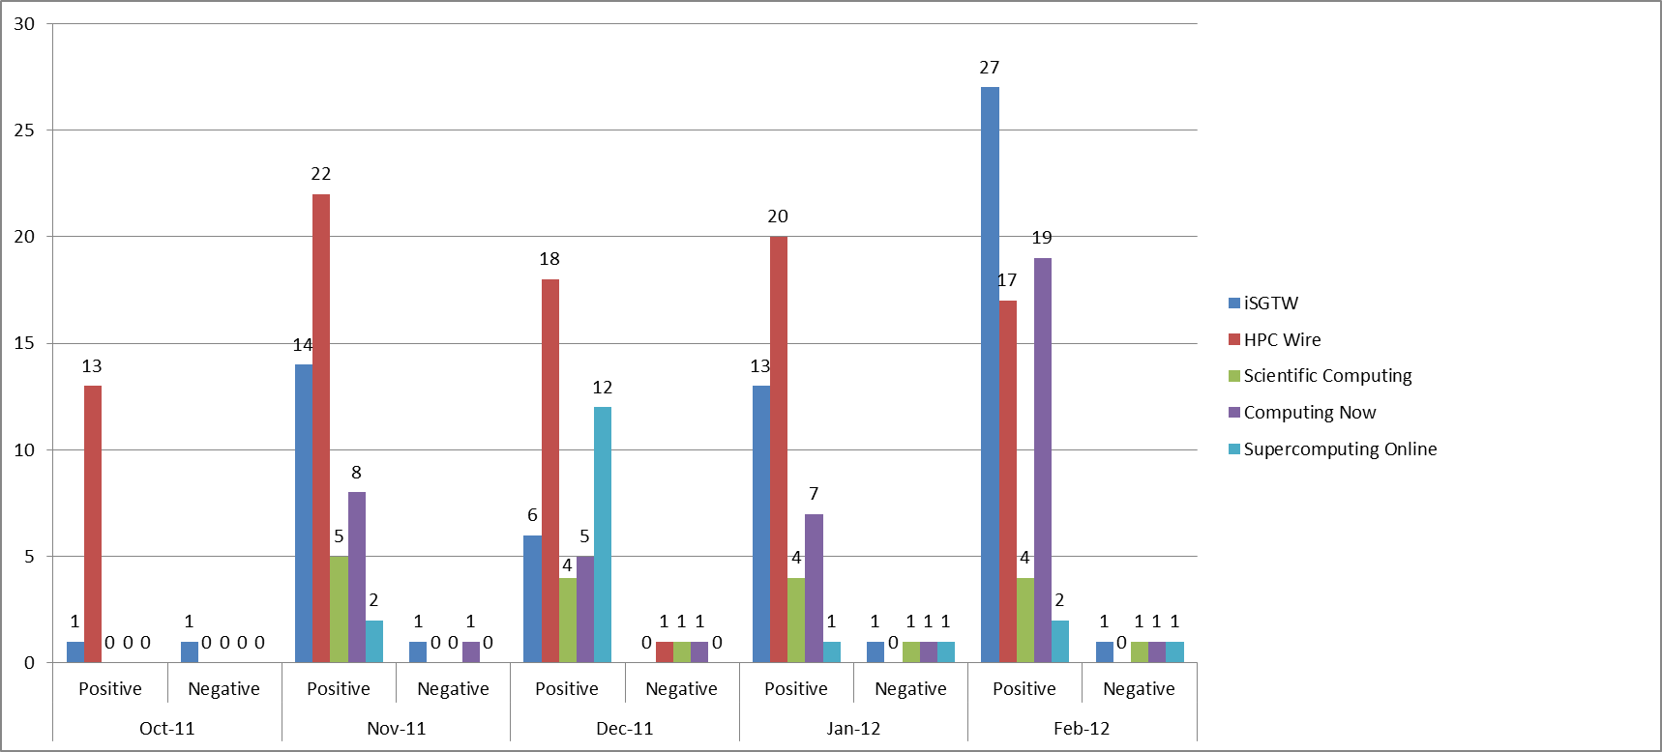

The y axis is a percentage measure of positive & negative comment ratios on Twitter. The ratio of positive to negative comments for iSGTW appears to have improved every month from November 2011 until now. In February, our sentiment ratio (96%:4%) was one of the highest when compared with our closest competitors. HPC Wire seems to have few, if any, negative comments month on month. Scientific Computing has a fairly consistent sentiment ratio.
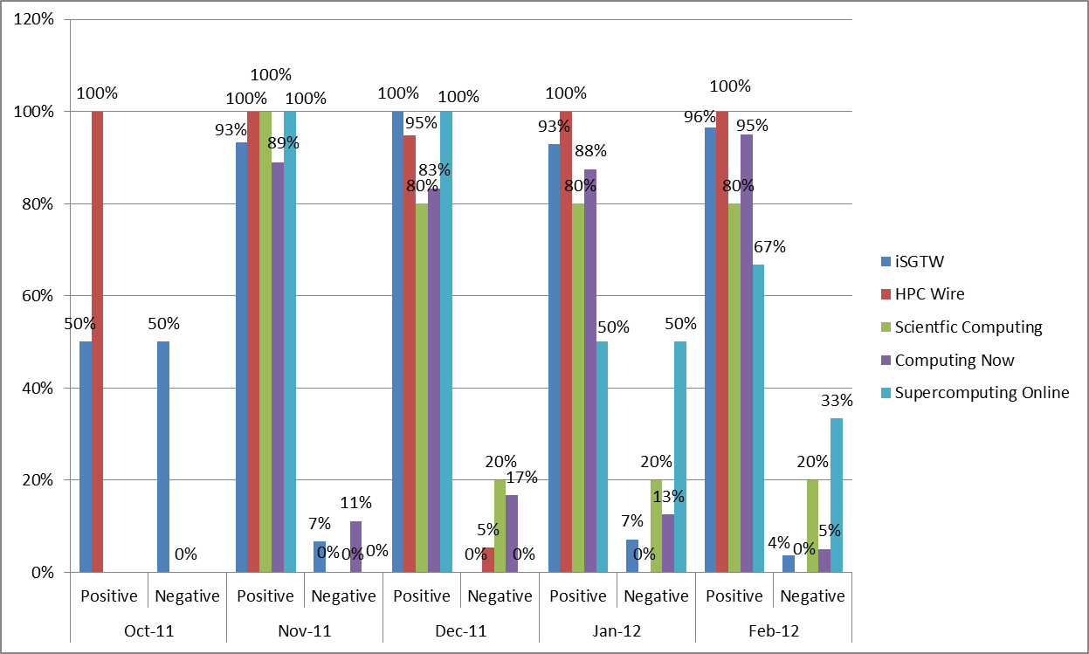

‘Passion’: It is a measure of the likelihood that individuals talking about your brand will do so repeatedly. For example, if you have a small group of very passionate advocates who talk about your products or brand all the time you will have a higher passion score. Conversely, if every mention is written by a different author, you will have a lower score.

Since December 2011, the passion score for iSGTW and our closest competitors has been rising. iSGTW’s passion score is 9% higher than 5 months ago. Computing Now is the only brand that appears to have a steadily increasing group of passionate advocates over a 5 month period.

In April 2012, Computing Now, Datanami and Symmetry Magazine continued to increase in passion score. ISGTW continues to fall.

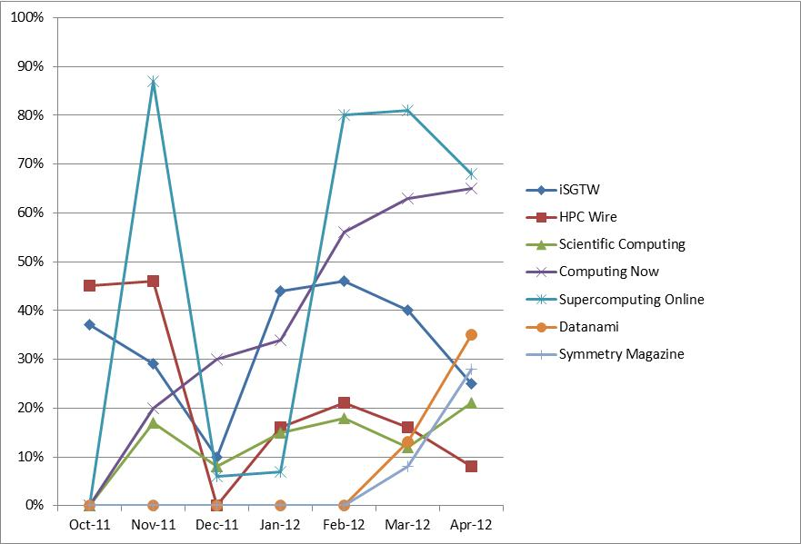

‘Reach’: A measure of range of influence. It is the number of unique authors referencing your brand divided by the total number of mentions.

iSGTW’s reach has increased by over 20% since October 2011. However, the only brand whose reach appears to be increasing month on month is Supercomputing Online.

In April 2012, iSGTW increased its social media reach more than all our competitors.
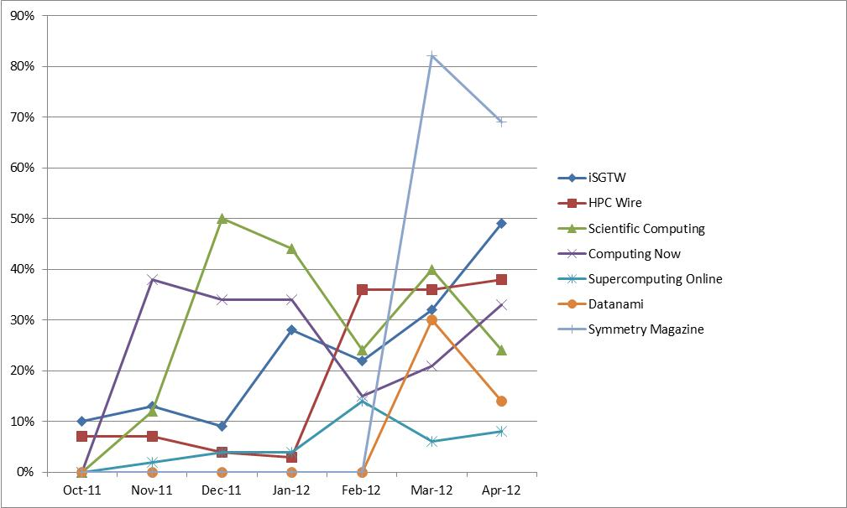

Location on CERN shared workspace:
\\cern.ch\dfs\Workspaces\i\iSGTW_Shared\iSGTW Documents\Monthly_Status_Upates

