EGEE

Transition Plan and Procedures for TSA1.3

Middleware Roll-Out

 | Document identifier: | input.docinput.doc
 | Date: | 08/02/10
 | Country: | Spain (ES) and Portugal (PT)
 | NGI: | Ibergrid: NGI-ES + NGI-PT
 | Document status: | DRAFT
 | Document link: | https://edms.cern.ch/document/xx/

Date | Version and Comments | Authors
08/02/2010 | Version 1.0: compilation of the first draft | Mário David
08/03/2010 | Version 2.0: Complete re-work on the doc | Mário David
12/03/2010 | Version 2.1: comments and additions, plus diagram | Jorge Gomes
17/03/2010 | Version 2.2: other mw testing processes + itil diagram | Mário David/Javier Lopez
26/03/2010 | Version 2.3: includes comments from G. Borges | Mário David
31/03/2010 | Version 2.4: includes comments from S. Newhouse | Mário David

Abstract: This document describes the transition plan and procedures for the middleware rollout from the current EGEE III SA1 task to EGI-InSPIRE global task TSA1.3 coordinated by Ibergrid.

Introduction

Purpose of this document
The present document details a plan for the transition of the EGEE SA1 activity known as “Middleware rollout” to EGI-InSPIRE Operations Unit TSA1.3.
The aim is the coordinated rollout of new Grid middleware versions to the production infrastructure.
In EGEE, this activity is comprised of the following two components:
- Pilot service.
- Staged rollout.

References

R1 - IBERGRID TRANSITION PLAN TO THE NATIONAL GRID INFRASTRUCTURE BASED MODEL.
R2 - https://twiki.cern.ch/twiki/bin/view/EGEE/MiddlewareSupportJobDescription
R3 - https://twiki.cern.ch/twiki/bin/view/EGEE/ProductTeams
R4 - https://www.egi.eu/indico/materialDisplay.py?contribId=2&sessionId=2&materialId=slides&confId=3
R5 – Check and include “EGEE Deliverable regarding the middleware lifecycle”

Acronyms
EA | Early Adopters
EMI | European Middleware Initiative
MU | Middleware Unit
OU | Operations Unit
PS | Pilot Service
PT | Product Team
SR | Staged-Rollout
MW | Middleware
UMD | Unified Middlware Distribution

Transition plan

Introduction and considerations on the present status
The gLite MW stack has the following structure:
- Node types: comprises several services.
- Service.
- Client: collection of client libraries, binaries and API's of the services.
- Transversal to all services and/or node types: information service, yaim configuration.

The versioning is done primarily in a global gLite release. The supported versions (as of 8 March 2010), are:
- gLite 3.1: supported for Scientific Linux 4 i386 and x86_64 architectures.
- gLite 3.2: supported for Scientific Linux 5 x86_64 architecture, and the clients also supported on Debian 4 x86_64.

Each gLite release is composed of node types and services with their own version scheme. When a given service is updated, version change, all node types dependent on that service will get their version also updated.

The document [R2] has a detailed description of the MW deployment procedure to production. This activity consists of two independent procedures:
- Staged rollout (SR).
- Pilot services (PS).

The SR is the evolution from the processes previously implemented in the Pre-Production Service consisting in an infrastructure independent from the production one, where MW components where deployed before the actual release into production. The SR process should be done in services integrated in the production infrastructure.

The sites participating in the Pre-Production Service, are presently discontinuing those services and deploying them in the production infrastructure. The SR activity has a mix of sites which either still participate in the Pre-Production Service, or that have already deployed the services in the production infrastructure.

“Proposal” procedures for EGI InSPIRE
EGI InSPIRE will use the MW provided by the European Middleware Initiative project (EMI), and other external and internal sources. EMI will provide the Unified Middleware Distribution (UMD). A given UMD release will be composed of a set of services with a given base release provided by Product Teams (PT).

Services from the gLite, ARC and Unicore MW stacks will be included in the UMD.
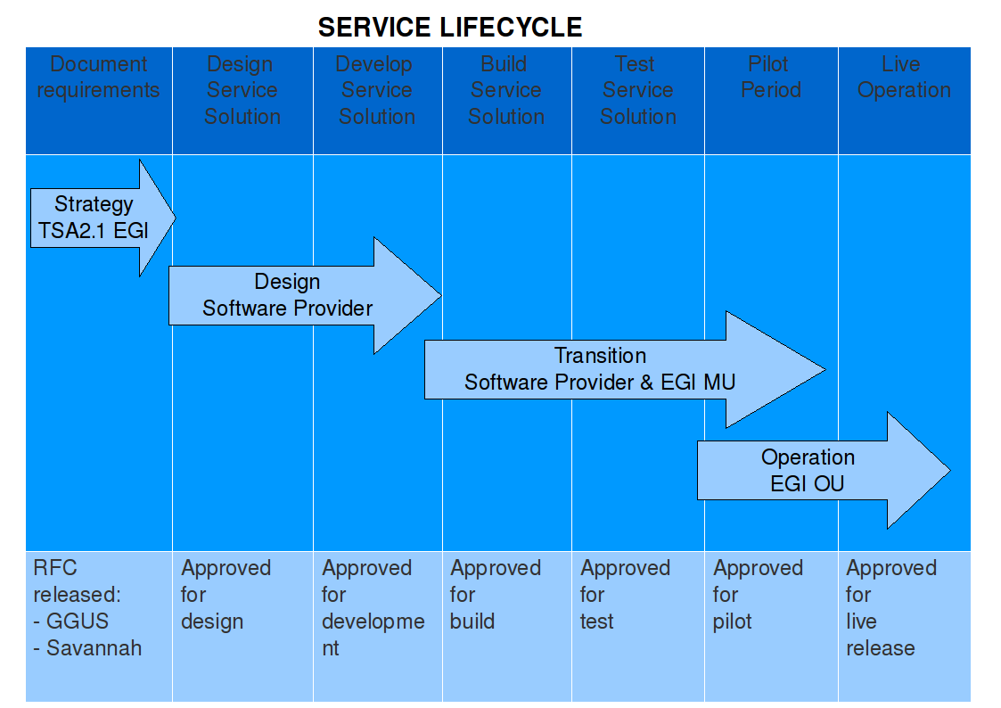Figure 1: Software lifecycle.

2.2.1 Version scheme and MW components update

A new version of any MW component falls on one of the following categories:
- Emergency (when needed): bug fixes, or security vulnerability, backward compatible.
- Revision release (at most once every two weeks): bug fix, backward compatible.
- Minor release (at most once per month): new functionality, backward compatible.
- Major release (at most twice per year):
  - New functionality not necessarily backward compatible.
  - New service.

For a given UMD major release, any given MW component can be updated only up to a “Minor Release”. The “Major Releases” of any given component may only be included in the next major UMD release, dependent on the roadmap.

All categories of updates to the components will undergo the SR procedure, though the timelines and depth of the SR may vary with the category. The sole exception is an Emergency release, for which, under exceptional circumstances to be evaluated in a case by case basis, may skip the SR.

EGI-InSPIRE will accept only certified and validated updates provided by the PTs. The validated components will undergo the SR procedure, and if successful can then be widely deployed in the production infrastructure.

In the SR phase, if bugs or issues are found in a given component for which some solution or workaround is proposed, the fix(es) should be communicated and implemented by the PT. MW components with workarounds to bugs or issues should be avoided in production.

The UMD release will be based on services, which may affect one or more node types, as opposed to the situation in EGEE where the releases are based on node types.

As such, it is the responsibility of the EGI-InSPIRE MU, to provide requirements for the integration of services into node types as is the case in gLite MW.

2.2.2 Operational tools for the MW rollout task
The PTs will interact/communicate with the MU using the tools provided by EGI-InSPIRE. Those tools will be under the “egi.eu” domain. At least the following tools should be provided:
- wiki: documenting all releases with deployment advisories, should have links to release notes, certification and validation of components provided by the PTs. The “wiki” is already setup in:
  - Top level: https://wiki.egi.eu/wiki/Main_Page
  - For the MW rollout process: https://wiki.egi.eu/wiki/Middleware:Release_Process
  - Should have links to the monitoring (nagios, gridview) of all services participating in the SR. Filter the services based in GOCDB tag “beta”. This may give an integrated view of the quality of these services, and eventually of the MW component.
- Progress tracking and task tool: follow all the MW process from the moment it is declared ready and made available by the PTs until released into production.
  - Manage all the SR process. Creation of task teams for each service in SR, should have notification and reporting capabilities. To record and display the effort of each team. Define and display metrics for the effort and for the usage of the service during the period of SR.
  - Feedback to the Software Providers.
  - Should have interface with GGUS.
  - Should have interface with GOCDB. Fetch the site names (and IDs), get the services tagged as beta, eventually other information.
- Early Adopters Portal: web form where sites can subscribe to do the SR as Early Adopters (EA), it should be easy to inject this information in “Progress tracking and task tool” in order to create the “squad” associated to any given SR service.
  - A site subscribes as EA.
    - Site name: it should be selectable from the GOCDB.
    - Responsible persons: site squad.
    - Services which the site proposes to perform the SR: all that where tagged “beta” in the GOCDB, and eventually others which are not tagged and the squad decide to do the test in a production instance.
  - The coordinator is notified.
  - If needed, the coordinator contacts the site for more information and planing.
- Repositories: for all UMD releases. This is the aim of task TSA2.4. MW components will be pushed by the Software Provider to these repositories. Some details about the implementation and usage of these repositories can be found in [R4].

2.2.3 Service Level Agreements
In order to guarantee the final Service Level Agreements (SLA) with the Virtual Organizations and Virtual Research Centres, Operational Level Agreements (OLA) should be established following the best-practices defined in ITIL. In this case OLAs should be agreed between:
- Software Providers (EMI and others) and EGI Midleware Unit.
- In a longer term, between EGI Midleware Unit and EGI Operations Unit.

The terms of these agreements should be discussed but should cover important aspects like:
- A common Configuration Management Database (CMDB): A database used to store relevant information about each of the middleware components part of UMD and the relationships between them.
- Definitive Media Library (DML): One or more locations in which the definitive and approved versions of all the middleware components are stored. Should be part of the repository information.
- Release Unit: Components that will be normally released together.
- Release Identification: A naming convention used to uniquely identify a Release.

2.2.4 MW rollout: Early Adopters
An Early Adopter is a site which has committed to perform the SR for one or more MW components or services and report that test . The following situations may occur:
- The site deploys a new service in parallel with the production instance, just for the SR process.
- The site may have a clone of the production system, where the new version is deployed, but if some problem occurs, the instance can be quickly changed to the one initially in production.
- The site preforms the SR in the production instance itself, having rollback procedures in place in case of problems.
This decision should be made by the EA, though it can have input from the Operations Team. Some further consideration may have to be taken into account. A node type can be divided into:
- Non-Critical: CE's, WMSs, clients (UI, WNs)
- Critical : SE's and Catalog services (LFC, AMGA, etc.), VOMS server.

Middleware services affecting Non-Critical node types are easier to release into a production environment. Problems or bugs that may arise will have in general a limited impact to the users and the site.

On the other hand, middleware services affecting Critical node types will have to be dealt more carefully, so has not to lead to data loss or major infrastructure availability blackout.

The MW services affecting the information system are another component where special care must be taken. At the level of a “Top-BDII” and the “Site-BDII”, it may be advisable to have an instance running in parallel or cloned from the one in production.

Whatever the procedure that the site decides to follow in the SR process, it must be taken into account that the site “Reliability and Availability” should not be affected if problems occur due to the new versions of the MW components. For that purpose the services in the SR must be tagged as such in the GOCDB.

2.2.5 Engagement of Early Adopters

Presently there are several sites which participate in the Pre-Production service, some of those sites have moved services to the production infrastructure, and others are in the process of doing so. This is one essential step towards the adoption of the SR procedure, and for those sites to become EAs.

A list of sites participating in the SR can be found in:
http://egee-pre-production-service.web.cern.ch/egee-pre-production-service/index.php?dir=./panel/

A mailing list has been created containing the contacts of these sites: early-adopters@cern.ch. New participants in the SR should be automatically subscribed in this mailing list. This mailing list must be migrated to the EGI domain. The proposal is: early-adopters@mailman.egi.eu.

It is expected that most of these sites will form the core of the SR, assuring the continuity of this activity with the least disruption as possible during the transition phase from EGEE to EGI. It is known that some of the sites, and possibly most will continue beyond EGEEIII assuring this task during the transition. Known exceptions are CERN and KIAM from the Russian ROC, which will decommission their PPS sites.

It is expected that the NGIs that have requested effort in the EGI-InSPIRE proposal for this task, will commit sites to SR as early as possible.

These set of sites should form a stable core of the SR process. There might be sites that will commit to the SR process only for a limited period of time or only for certain releases of some MW component.

Requesters of new functionalities or new services, if approved, should be required to engage in the SR phase eventually committing new sites.
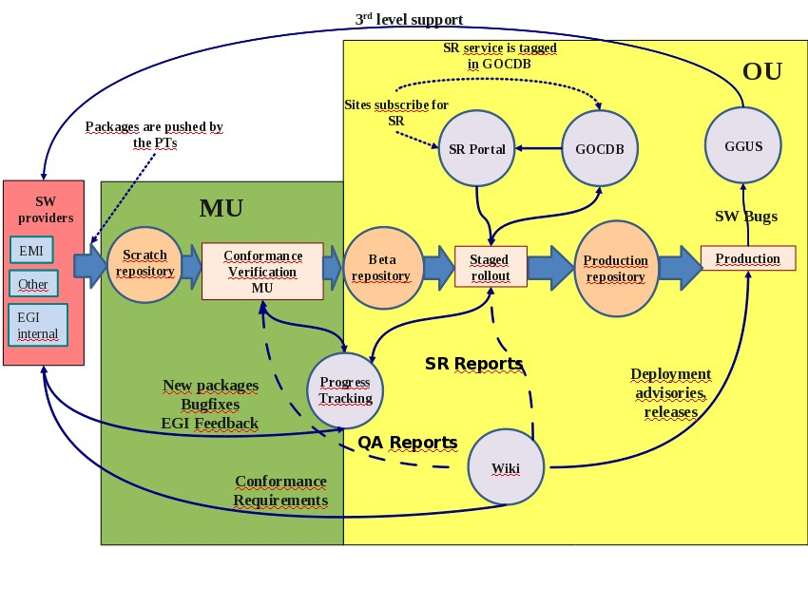Figure 2: Middleware rollout cycle.

2.2.6 Pilot Services and other MW testing processes
The Staged Rollout is the most usual process to release new middleware component versions into the production infrastructure. Nonetheless, other processes for middleware testing may occur:

- Pilot services:
  - Occasionally it may be justified to setup this process when a new middleware component has to be integrated with existing components, introducing the client first and the server only at a later step, with careful testing at all stages. Example: ARGUS the EGEE Authorization Service.
  - Middleware components may need strengthening, improve robustness, test under high loads with configuration tuning. Example: CREAM-CE Computing Element.
- Testing Alpha and Beta releases of middleware components under development. In particular complex and critical middleware components. Examples: dCache and StoRM Storage Elements, File Transfer Service (FTS).
On any of the cases described previously, there is a tight collaboration between the interested parties; a set of sites, users communities and the developers of the component. It is usual that the versions of these middleware components are deployed and used in production by the participating sites and user communities, before they reach the production repositories for general availability.

Nonetheless, though these components went under heavy testing when they reach the EGI Scratch repositories, they should still be put under the Staged Rollout process.

