EGI-InSPIRE

DMP0: METRICS PORTAL ROADMAP V1

 | Document identifier: | input.doc
 | Date: | 29/07/26
 | Activity: | JRA1
 | Lead partners for deliverable: | CESGA
 | Document status: | DRAFT
 | Document link: | http://www.egee.cesga.es/documents

Abstract: This document provides the development roadmap of the Metrics Portal for the next 3 years.

- Copyright notice
Copyright © Members of the EGI-InSPIRE Collaboration, 2010. See www.egi.eu for details of the EGI-InSPIRE project and the collaboration. EGI-InSPIRE (“European Grid Initiative: Integrated Sustainable Pan-European Infrastructure for Researchers in Europe”) is a project co-funded by the European Commission as an Integrated Infrastructure Initiative within the 7th Framework Programme. EGI-InSPIRE began in May 2010 and will run for 4 years. This work is licensed under the Creative Commons Attribution-Noncommercial 3.0 License. To view a copy of this license, visit http://creativecommons.org/licenses/by-nc/3.0/ or send a letter to Creative Commons, 171 Second Street, Suite 300, San Francisco, California, 94105, and USA. The work must be attributed by attaching the following reference to the copied elements: “Copyright © Members of the EGI-InSPIRE Collaboration, 2010. See www.egi.eu for details of the EGI-InSPIRE project and the collaboration”. Using this document in a way and/or for purposes not foreseen in the license, requires the prior written permission of the copyright holders. The information contained in this document represents the views of the copyright holders as of the date such views are published.

- Delivery Slip
 | Name | Partner/Activity | Date
From | Alvaro Simon | CESGA/JRA1 | 18/01/11
Reviewed by | Moderator:  Reviewers:
Approved by | AMB & PMB

- Document Log
Issue | Date | Comment | Author/Partner
1 | 18/01/11 | First draft entering internal review | A. Simon/CESGA
2 | 19/01/11 | New charts and gantt | J. Lopez/CESGA
3 | 20/01/11 | Revision | J. Lopez/CESGA

Content

1.Introduction 4
1.1.Purpose of the document 4
1.2.Application area 4
1.3.references 4
1.4.Document amendment procedure 4
1.5.Terminology 4
2.Executive summary 5
3.WBS 6
4.WBS Dictionary 7
5.LIST OF DELIVERABLES 9
6.LIST OF Milestones 10
7.schedule 11

Introduction

Purpose of the document
This document shows new Metrics Portal roadmap and future deliverables and milestones. A preview Gantt chart is displayed at the end of this document.

Application area
Readers can use this document to obtain general info about Metrics Portal status and future work.

references
[R1] http://metrics.egi.eu | Metrics Portal
[R2] http://accounting.egi.eu | Accountig Portal
[R3] http://www.ggus.org | GGUS Portal
[R4] http://cic.gridops.org/index.php | Operations Portal
[R5] https://goc.gridops.org/site/list?id=112 | GOCDB

Document amendment procedure
This document may be updated as new services appear to be included into Metrics Portal or if new milestones are required.
Comments should be sent to the authors.

Executive summary
The development roadmap of the Metrics Portal for the next 3 years is presented.

The document includes the WBS, WBS dictionary, list of deliverables, list of milestones and the schedule.

The development is based on the spiral model. Three complete cycles are defined, producing a new release of the metrics portal at the end of each cycle.

Inside each cycle there are six steps, one devoted to each data source. After each step a preview release including the additional metrics created will be available in the development version of the metrics portal for internal review.

The detailed schedule is presented in Section 8.

Introduction
The metrics portal is the culmination of the work initiated by the MIG (Metrics Implementation Group) and transferred to the Operations Automation Team (OAT) in EGEE-III and now to EGI. The main objective is to have a set of metrics that can help to measure project performance and keep track of its evolution. The portal automatically collects all the required data and calculates these metrics displaying all of them in a single place. The portal agglutinates information from different sources like GOCDB, GGUS, GSTAT, etc. using various connectors depending on the data provider. These connectors translate the information gathered from diverse producers and stores it into a local database. Using the metrics portal this information will be available from a common interface and full reports could be generated in just a few seconds.

Project life cycle

The development of the metrics portal is based on the A spiral life-cycle model. Three complete cycles are defined, producing a new release of the metrics portal at the end of each cycle (see Figure 1).

Inside each cycle there are six steps, one devoted to each data source. After each step a preview release including the additional metrics will be available in the development version of the metrics portal for internal review.

Before each step in the life-cycle dedicated meetings will be organized with activity leaders to define the set of metrics to implement and with the corresponding data provider to define the OLA for data access. These meetings will take place one month before the beginning of the development so enough time is given to each data provider to give access to the data required to produce the selected metrics.

Figure 1: Metrics Portal Lifecycle

WBS

MP0 | Coordination
MP1 | Current Metrics Portal revision
MP2 | Metrics Portal Framework
MP3 | Manual Metrics
MP4 | Accounting Metrics
MP5 | GGUS Metrics
MP6 | GSTAT Metrics
MP7 | ACE Metrics
MP8 | GOCDB Metrics

WBS Dictionary

Code | MP0
Name | Coordination
Definition | Develop project plan and coordinate project development through dedicated meetings both with activity leaders and data providers
Deliverables | DMP0.1 DMP0.2 DMP0.3
Milestones

Code | MP1
Name | Metrics Portal V1.1
Definition | Review current version of Metrics Portal
Deliverables | DMP1
Milestones | MMP1

Code | MP2
Name | Metrics Portal Framework
Definition | The aim of this work package is to choose a framework fast and versatile to develop version 2 of the portal
Deliverables | DMP2
Milestones

Code | MP3
Name | Manual Metrics
Definition | Define a database schema and the interface to introduce manual metrics into the portal
Deliverables | DMP3.1 DMP3.2 DMP3.3
Milestones | MMP2 MMP3 MMP4

Code | MP4
Name | Accounting Metrics
Definition | Definition and implementation of required metrics available from Accounting Portal
Deliverables | DMP4.1 DMP4.2 DMP4.3
Milestones | MMP2 MMP3 MMP4

Code | MP5
Name | GGUS Metrics
Definition | Definition and implementation of required metrics available from GGUS
Deliverables | DMP5.1 DMP5.2 DMP5.3
Milestones | MMP2 MMP3 MMP4

Code | MP6
Name | GSTAT Metrics
Definition | Definition and implementation of required metrics available from GSTAT
Deliverables | DMP6.1 DMP6.2 DMP6.3
Milestones | MMP2 MMP3 MMP4

Code | MP7
Name | ACE Metrics
Definition | Definition and implementation of required metrics available from ACE
Deliverables | DMP7.1 DMP7.2 DMP7.3
Milestones | MMP2 MMP3 MMP4

Code | MP8
Name | GOCDB Metrics
Definition | Definition and implementation of required metrics available from GOCDB
Deliverables | DMP8.1 DMP8.2 DMP8.3
Milestones | MMP2 MMP3 MMP4

LIST OF DELIVERABLES

Deliverable | Name | Description
DMP0.1 | Metrics Portal Project Plan v1.0 | Portal roadmap deliverables.
DMP0.2 | Metrics Portal Project Plan V1.1 | Metrics Portal Project Plan update after first development cycle
DMP0.3 | Metrics Portal Project Plan V1.2 | Metrics Portal Project Plan update after second development cycle
DMP1 | Metrics Portal v1.1 | Minor release based on the version of the Metrics portal based on current release. Basically fixing open bugs.
DMP2 | Framework selection | New development framework selected for Metrics Portal V2
DMP3.1 DMP3.2 DMP3.3 | Manual Metrics v1 v2 v3 | Portal interface will grant write access to activity leaders to introduce manual metrics
DMP4.1 DMP4.2 DMP4.3 | Accounting Metrics v1 v2 v3 | Metrics Portal should display metrics using stored accounting information.
DMP5.1 DMP5.2 DMP5.3 | GGUS Metrics v1 v2 v3 | GGUS and Metrics Portal teams should be in contact to deploy a stable interface between portals and store and display the desired metrics.
DMP6.1 DMP6.2 DMP6.3 | GSTAT Metrics v1 v2 v3 | New set of metrics gathering information from GSTAT.
DMP7.1 DMP7.2 DMP7.3 | ACE Metrics v1 v2 v3 | Display new metrics using GOCDBPI interface.

LIST OF Milestones

Milestone | Description
MMP1 | Metrics Portal v1.1
MMP2 | Metrics Portal v2
MMP3 | Metrics Portal v2.1
MMP4 | Metrics Portal v2.2

Schedule

DATE | EVENT
31/01/11 | DMP0.1
28/02/11 | DMP1 DMP2 MMP1 (Metrics Portal v1.1)
31/03/11 | DMP3.1
30/04/11 | DMP4.1
31/05/11 | DMP5.1
30/06/11 | DMP6.1
31/07/11 | DMP7.1
31/08/11 | DMP8.1 MMP2 (Release 1)
30/09/11 | DMP0.2 DMP3.2
31/10/11 | DMP4.2
30/11/11 | DMP5.2
31/12/11 | DMP6.2
31/01/12 | DMP7.2
28/02/12 | DMP8.2 MMP3 (Release 2)
31/03/12 | DMP0.3 DMP3.3
30/04/12 | DMP4.3
31/05/12 | DMP5.3
30/06/12 | DMP6.3
31/07/12 | DMP7.3
31/08/12 | DMP8.3 MMP4 (Release 3)

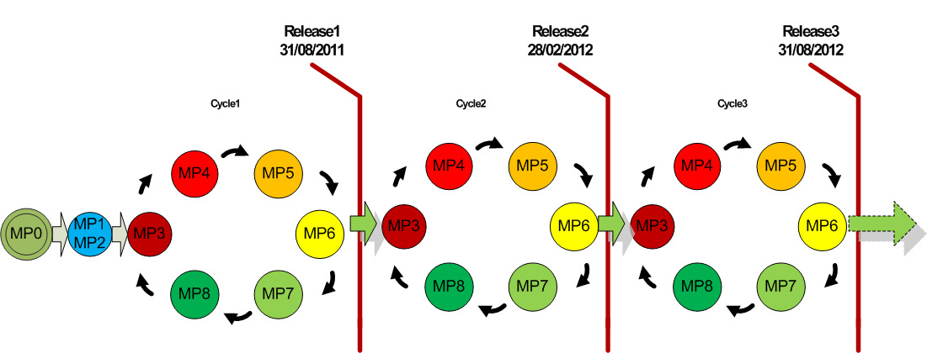Figure2: Release Schedule

One release will be produced each 6 months. In Figure 2 the release schedule is presented.

NOTE:
Before each step in the life-cycle two dedicated meetings will be organized:

- The first one will involve activity leaders to define the set of metrics to implement
- The second one will involve the corresponding data provider to define the OLA for data access

These meetings will take place one month before the beginning of the development so enough time is given to each data provider to give access to the data required to produce the selected metrics.

The specific dates for each meeting have to be defined.

