**ICOS Carbon Portal Usecase: Footprint Tool**

This is a short description of the work- and dataflow, storage and computation requirements of the usecase and its implementation with EGI and EUDAT services. It only serves as a basis for discussions between EGI, EUDAT and ICOS on the implementation of the usecase. The strategy is still open for discussion and the description is not yet complete. **More information will be added as required during the discussion.**

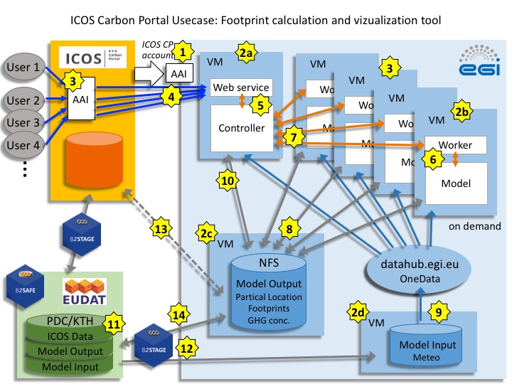

**General work- and dataflow:**

(Numbers correspond to those in figure above)

*(Open issues in italic)*

**Workflow for setting up and providing the footprint tool service:**

**1**. ICOS CP instantiates several VMs in the EGI FedCloud to host the different parts of the usecase. A robot certificate associated to ICOS CP is used for the authentication and authorization in the EGI FedCloud and for EUDAT B2STAGE/B2SAFE-services.

**2**. ICOS CP runs containerized versions of the services on these VMs:

1. VM hosting the **web interface** for request of model runs and visualization of the results and the **controller** for load balancing and container orchestration (based on Akka Cluster akka.io). Prototype: 8CPUs, 16 GB RAM
2. VM hosting the **worker** for starting model runs and sending back log files and the **transport model** computations. (More VMs might be needed depending on the demand.) Prototype: 8 CPUs, 32 GB RAM (+ 2 TB local storage)
3. VM with large block storage attached with **NFS** to store model output data produced on one or more VMs. Prototype: 4 CPUs, 16 GB RAM + 2 TB storage
4. VM hosting OneProvider with large block storage attached to store parts of the input data for the computation (4D meteorological reanalysis). Prototype: 4 CPUs, 16 GB RAM, 2 TB storage

Requirements for VM size and storage space are still provisional.

The VMs (2a, b, c, d) are running continuously. The ICOS CP DNS record for the service (stilt.icos-cp.eu) does not point directly at an IP address, but redirect to another domain name, which will be resolved by a dynamic DNS provider. The VM (2a) has a dynamic DNS client installed, which updates the dynamic DNS record on VM startup.

**Workflow for a user of the footprint tool service:**

(blue arrows)

**3**. The user accesses the service at ICOS CP. Authentication and authorization of the user is handled at ICOS CP. ICOS CP takes care of all interactions with the EGI FedCloud on behalf of the user.

**4**. The user is directed to the web service running on VM (2a).

**Information flow inside the footprint tool:**

(orange arrows)

**5**. The web service provides the user interface to initiate model runs and visualize results. Input parameters (geographic coordinates and time span) are selected on the web interface and passed to the controller. The controller distributes the jobs to the required number of cores/VMs. Input parameter are passed to the worker node(s) on the VM(s) for the model runs. The controller also initiates the creation of additional VMs if required.

The web service serves several users in parallel and the controller launches separate specific model runs.

**6**. Model computations are hosted in a separate VM. As the model runs only on a single CPU, parallel model runs are possible. Each model run is further spilt into small jobs to allow easy distribution over many cores/VMs to efficiently serve multiple users.

**7**. Log files from the model run are transferred back to the controller and displayed on a dashbord in the user interface.

**Data flow inside the footprint tool:**

(grey arrows)

**8**. Model output is written to a common Network File System. The model output data might be re-used in further model runs if the same station and (partly) the same time slots are requested. Therefore output data from all previous runs should be available to the model run. Model output (particle location files, footprints, concentration time series) constists of a large number (∼1 Mio) of small files (1-5 MB).

**9**. Model input (4D meteorological reanalysis, emissions maps) files are stored on block storage attached to a VM hosting OneProvider and access is managed through the EGI datahub. The access of data from multiple providers might be a useful application.

**10**. Model output is displayed on the web interface and the user can also download the results to her/his local computer.

**Data storage and transfer:**

(light blue arrows)

**11**. Quasi-static input data (incl. metadata) are stored on the ICOS CP server and for longterm storage in B2SAFE (at PDC/KTH), data transfer using B2STAGE.

**12**. A copy of the input data is transfered using B2STAGE from B2SAFE to the storage attached to the VM hosting OneProvider and to the storage attached to the VM hosting the NFS. Regular updates needed when new datasets become available.

**13.** Datasets not stored in B2SAFE, eg. intermediate versions of model output, are directly transferred from the ICOS CP server the VM hosting the NFS.

**14**. Model output data *(incl. metadata)* are transfered regularily to B2SAFE using B2STAGE and archived in B2SAFE for longterm storage.

*The strategy to attach a PID (or DOI) to the model output (and user-specified request) is not yet included.*

**Workflow inside the footprint model:**

Scenario 1: Visualization for existing ICOS sites

* Precomputed particle location files exist
* Footprints and time series exist for most sites and time ranges and emission types
* Check availability of footprints and time series files (if not available -> Scenario 2)
* Display results

Scenario 2: On-demand calculation for new sites or new time periods

* No precomputed particle location files exist
* Full STILT run required (compute particle location, footprint, concentration time series)
* Computations may require several hours to days
* Display results

Detailed workflow:

* Select time range and station (name-id or latitude/longitude)
* Check availability of aggregated footprints (netCDF-files) and of time series (csv-file) for full time range and all emission types
  + For each date (year, month, day, hour):
  + If footprint or particle location file not available
    - Compute particle location file if this is not yet existing (new station and/or new time period)
    - Compute footprint for this date and store (in netCDF-file)
  + Compute concentration for this date based on particle location and emissions, append result to csv-file

-> Display time series and animation of footprints in web service

**Implementation of the visualization of footprints and time series at ICOS Carbon Portal:**

<https://data.icos-cp.eu/stilt/>

**Test implementation of on-demand calculation and visualization of footprints and time series - still under development:**

<https://stilt.icos-cp.eu/worker/>

**Storage requirements:**

* Input datasets (quasi-static, updated every 6-12 months)
* Emissions (EDGAR, VPRM and more)
* Initial and boundary concentration data
* Meteorology
* Particle location files (precomputed for many stations and dates)
* Observation time series

|  |  |  |  |  |  |  |
| --- | --- | --- | --- | --- | --- | --- |
| Input dataset |  | no of files  per year | File size | Storage  per year | Total storage  10 years | Type |
| Emissions | EDGARv4.1 | 3 | 6.3 GB | 19 GB | 0.19 TB | netCDF |
| EDGARv4.3 | 250 | 1-10 MB | < 1 GB | 0.01 TB | netCDF |
| VPRM | 10 | 1-6MB | < 1 GB | 0.01 TB | netCDF |
| others | 3-10 | 20-100 MB | < 1 GB | 0.01 TB | netCDF |
| Boundary |  | 5 | 1-10 GB | 20 GB | 0.20 TB | netCDF |
| Meteo |  | 12 | 17 GB | 204 GB | 2 TB | arl (binary) |
| Particle location  per station  all available | 1-3 hourly | 2920-8760 | 0.5-5 MB | ~ 20 GB | ~ 20 TB | R-object |
| 90 stations | ~ 400000 | 0.5-5 MB | ~ 2 TB |

* Output datasets

(model runs access output data from previous runs and eventually add new files)

* + Aggregated Footprints
  + Concentration time series
  + Particle location files for new sites (produced in a full STILT run)

|  |  |  |  |  |  |  |
| --- | --- | --- | --- | --- | --- | --- |
| Output dataset |  | no of files  per year | File size | Storage  per year | Total storage  10 years | Type |
| Footprints  per station  all available | 1-3 hourly | 2920-8760 | 40 kB | < 300 MB | ~ 150 GB | netCDF |
| 90 stations | ~ 400000 | 40 kB | ~ 15 GB |
| user requests | new sites |  |  | ~ 20 GB | ~ 200 GB |
| Time series  per station  all available | 1-3 hourly | 1 | 1-10 MB | ~ 10 MB | ~ 10 GB | csv (ascii) |
| 90 stations | 90 | 1-10 MB | < 1 GB |
| user requests | new sites |  |  | 10 GB | ~ 100 GB |
| Particle location  per station | 1-3 hourly | 2920-8760 | 0.5-5 MB | ~ 20 GB | ------ | R-object |
| user requests | new sites |  |  | ~ 2 TB | < 20TB * |

*User requests will initiate computation of additial footprints and time series for approx. 100 new sites but for only 1-2 years.

**Computational requirements:**

Test on a linux cluster at MPI for Biogeochemistry in Jena and VM in EGI FedCloud

(*will add specification here)*

Full STILT run:

3 GB memory per job

670 CPU seconds per footprint

1700 CPU hours per station per year

*(more detailed information on cpu time etc. will be added)*

Model runs for individual stations and users requests are separate jobs therfore paralell processing is possible and required for better performance.