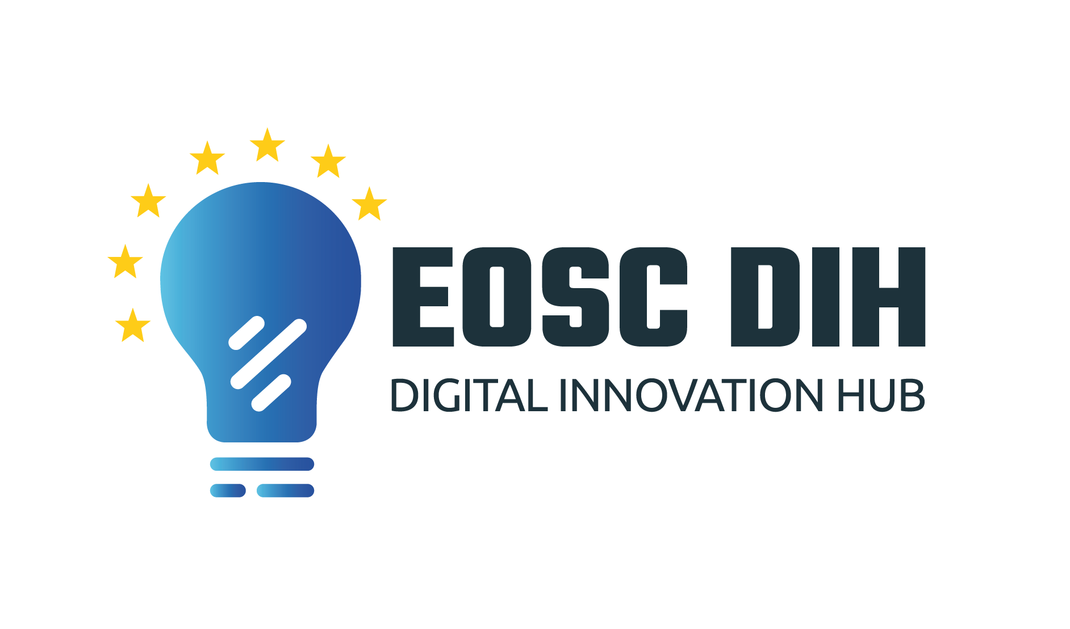
EOSC Digital Innovation Hub (EOSC DIH)
Memorandum of Understanding (MoU) and
Terms of Reference (ToR)

Document Link
Last Modified | 2021-03-30
Version | V6
Contact | business@eosc-dih.eu
Document Type | MoU/ToR
Document Status | Draft
Approved by
Approved Date

Table of Contents
Background 3
Purpose and Nature of this MoU 3
Partners’ Rights and Expected Contributions 3
Projects and Reports 4
Partners’ Meetings 5
Conduct of the Partner’s Meetings 5
Voting 6
Chair 6
Acceptance, Withdrawal and Removal of Partners 7
Evaluation 7
Amendments 8
Entry in Force and Termination 8
Miscellaneous 8
Resolution of Conflicts 8
ANNEX 1: Terms of Reference (ToR) 11

Background
The European Open Science Cloud Digital Innovation Hub (EOSC DIH) is an international and multi-partner cooperation that focuses on improving the competitiveness and innovation capacity of start-ups and SMEs by providing technical support and including indirect actions such as collaborations with incubators and research organizations, as well as improving the commercial innovation potential.

The EOSC DIH was set up by WP9 under the H2020 EOSC-hub project and was being designed to serve as the mechanism for business organisations (e.g. start-ups, SMEs, large enterprises) to directly engage with the European Open Science Cloud. EOSC-hub WP9 defined specific service offers to facilitate establishing business partnerships and business pilots to increase exploitation potential of commercially viable research data and other existing e-Infrastructure services while providing both human and technical services to commercial organisations to increase digitization capabilities and move new products or services into the market. The long-term strategy of the DIH was to live beyond the life of the project and to be the featured mechanism for industry to engage with the European Open Science Cloud.

The EOSC DIH in its current form shall therefore focus on supporting private industry in accessing the digital technologies and services offered by the European Open Science Cloud (EOSC) and facilitate industry focused partnerships across the ecosystem.

Purpose and Nature of this MoU
The purpose of this MoU is to create a framework for cooperation between the Partners regarding the establishment, governance and operation of the EOSC DIH, as described in Annex 1: Terms of Reference (ToR). The Partners’ participation in the EOSC DIH is voluntary, based on service to the community with not-for-profit purpose. However, it is expected that Partners are strongly committed to the purpose of the EOSC DIH activities.

This MoU does not constitute a binding contract, nor does it create any financial obligation on either Partner towards the other Partner (provided, however, that this shall not limit a Partner’s financial responsibility for its own costs and expenses).

The Partners agree to provide each other with all necessary information, and not to withhold information that is relevant for the implementation of this MoU.

Partners’ Rights and Expected Contributions
The rights of Partners shall include:
- Attendance and voting at the Partners’ meetings
- To be listed on the EOSC DIH website and relevant published material
- To invite up to two experts or third parties to attend specific sessions of a Partner’s meeting, provided this has been agreed by the Partners prior to confirming participation
- To be invited to participate in project funding proposals to support the EOSC DIH activities.

Each Partner is expected to:
- Maintain the EOSC DIH service catalogue
- Bear its own costs and expenses incurred in connection with performing the services offered and the activities connected with this MoU
- Seek to expand the scope and reach of services offered
- Disseminate and promote the EOSC DIH activities, onboard new business pilots and create new partnerships
- Serve as an interface with other DIHs, EC funded projects, and other relevant initiatives
- Actively participate in the annual and regular Partners’ meetings and EOSC community meetings
- Provide updates to other Partners on the status of the business pilots in which it is involved
- Organize, support, and participate in the DIH activities such as webinars, conferences and workshops
- Contribute to the circulation of relevant material such as funding opportunities, news or any other relevant information for the EOSC DIH community
- Contribute to the definition of the business models of the EOSC DIH
- Contribute to the governance and operation of the EOSC DIH, by striving to allocate 1 PM to support the services and activities above.

Projects and Reports
Nothing in the MoU shall prevent Partners to participate in projects with private financing and/or in projects with competitive public financing (national or European).

In the case of joint EU funding projects concerning the EOSC DIH, one (or more) Partners shall strive to act as a beneficiary and the other Partners may participate as "third party" or equivalent, according to the figure of Joint Research Unit (JRU) referred to in article 14 of the H2020 Annotated Model Grant Agreement.

Any participation in projects or project proposals which mention the EOSC DIH as a key activity must be communicated to the EOSC DIH Partners in advance and as soon as practically possible. Such communication shall not imply that any or all Partners are potential beneficiaries.

Any deliverable produced via a relevant EC funded project shall be shared, where possible, with the Partners.

An annual report will be produced by the Partners to summarize the key activities carried out by the EOSC DIH.

Partners’ Meetings
The Partners shall meet physically at least once a year for an annual meeting. In case objective reasons prevent such meeting from taking place physically, it may be conducted virtually.

Regular meetings will be held once a month and may be conducted virtually.

The Chair may call for additional meetings or extraordinary meetings, which may be conducted virtually.

Partners’ meeting shall be quorate if at least 50% of the Partners are present at a meeting.

Partners shall subscribe to the EOSC DIH mailing list and use it as the primary written communication channel.

To allow for low latency communications, Partner shall use a secure instant messaging service via a dedicated Slack channel.

Conduct of the Partner’s Meetings
The Chair shall circulate the agenda and relevant material at least 3 working days in advance of the Partners’ meeting, taking account of proposals submitted by the Partners.

The agenda items shall indicate if the item is brought for information or requires a decision.

Regular agenda items will be marked, at minimum, by the following categories:

- Administration aspects
- Status update regarding
- Ongoing business pilots
- Dissemination and promotional activities
- New or potential pilots and partnerships
- Review of all actions from previous meetings and assignment of new ones
- Agreement of date for the next meetings
- Any other business

At the beginning of each meeting the draft agenda shall be adopted by the Partners after any necessary modifications. New items may be added to the Agenda by the Chair, but they may only be subject to a decision if all Partners agree.

Delegates may only take the floor following permission to speak granted by the Chair. The Chair may call to order a delegate or an attendee whose remarks are irrelevant to the subject or inappropriate. The Chair may require a delegate or an attendee to leave the meeting room after calling him/her to order for three consecutive times during the meeting.

The Chair shall be assisted by any Partner in taking the minutes of the meeting, which is a shared duty amongst all Partners.

All documents shall be stored electronically and made available to Partners in a secured manner.

Voting
The Partners shall strive to reach decisions by consensus. If no consensus is reached after two consecutive group meetings, the Chair may decide to put the matter for voting, in which case, the majority rule shall be a simple majority.

Each Partner is entitled to one vote, with all votes being of equal value.

A Partner shall not have voting rights in decisions concerning that Partner’s removal from participation in the EOSC DIH and termination of its participation in this MoU.

Partners absent or abstaining from voting shall be counted as not voting.

In the event of a tie the Chair shall have a casting vote.

If a decision of the Partners is adopted following a vote, the minority positions shall be recorded and reported in the minutes.

Chair
The Partners shall elect a Chair and a Vice-Chair among the delegates of the Partners by a simple majority.

The Vice-Chair shall replace the Chair in cases of absence, resignation, inability to act or in cases of conflict of interest which cannot be otherwise resolved.

The term of office for the Chair and the Vice-Chair shall be two years, renewable (without limitation) for the same period each time.

The Chair and Vice-Chair may assume other roles in the EOSC DIH.

The following persons shall be appointed as Chair and Vice-Chair, until a new Chair and Vice-Chair are elected:

Chair: Sy Holsinger, EGI Foundation
Vice-Chair: Marcin Płóciennik, PSNC IBCh PAS.

the Chair shall:

- convene the meetings of the Partners
- ascertain the quorum required for the meeting and the majority in each voting
- determine the place and time of the Partners’ meeting (following consultation with the Partners)
- approve the proposed agenda to be circulated in advance of the Partners’ meeting, taking account of proposals submitted by the Partners.
- open and close the meeting and put forward proposals to vote and announce decisions
- manage the discussions and grant or withdraw permission to speak, as a general rule, in the order in which delegates express their desire to speak
- rule on points of order and conduct the meetings in accordance with this MoU
- Take the minutes of the meeting (or nominate another person to do so) and circulate them for approval within 3 working days after the last day of the meeting.

Acceptance, Withdrawal and Removal of Partners
Interested entities that wish to participate in the EOSC DIH as Partners shall submit an application form for inclusion via the EOSC DIH website, along with the motivation for joining.

Applications for becoming a new partner are subject to approval by the Partners at the time of submission following voting.

Partners may withdraw from this MoU at any time upon at least 6 months prior written notice to the Chair. A Partner that withdrew shall continue to contribute to the EOSC DIH in accordance with this MoU until withdrawal is effective.

The Partners shall have the power to remove a Partner from participation in the EOSC DIH and terminate its participation in this MoU if the following conditions are met:

- The Partner has acted in a manner that is contradictory, undermines, or risks to undermine the provisions of this MoU or the purpose of the EOSC DIH
- The Partner has failed to rectify its action or inaction (as the case may be) within a period of 6 months after given notice by the Chair
- The Partner was given the opportunity to present its position at the Partners’ meeting before the decision is made
- The decision has been voted in favor by at least 80% majority of the Partners present at the meeting.

Evaluation
The Partners shall strive to conduct a semiannual survey in order to collect feedback from both the EOSC DIH Partners as well as the community members to gauge the effectiveness as well as suggestions for improvement for the functioning of the EOSC DIH.

Amendments
Any modification of the MoU requires the written agreement by all signatories.

The Partners agree to review this MoU, ideally once a year.

Entry in Force and Termination
This MoU will come into effect between the signatories that have signed it as of the date of its second signature. It will then come into effect regarding each additional signatory that signs it after this sate as of the date of signature by said signatory.

All or individual signatories may decide to terminate this MoU in accordance with clause 9 or by agreement of all signatories.

Miscellaneous
Annexes to this MoU form an integral part thereof.

The MoU is drawn up in English, the language which will govern all documents, notices, meetings and process relative thereto.

Resolution of Conflicts
Conflicts arising in relation to this MoU shall be settled amicably. Any disagreement that cannot be settled amicably shall be escalated to the Chair who shall propose a solution.
If no amicable solution is found, the concerning Partner/s may withdraw from this MoU.

Glossary and Definitions

This table provides the key terms used throughout this document for reader orientation.

Term | Definition
EOSC | European Open Science Cloud
DIH | Digital Innovation Hub
Founding partners | Member organizations of the DIH, signatories of this MoU.
The Partners | Founding organizations and new organizational members that supports the goals and service provision of EOSC DIH and have signed this MoU
DIH services | Services provided by the DIH and agreed under an SLA
SLA | Service Level Agreement
MoU | Memorandum of Understanding
WP9 | Work Package 9 “Joint Digital Innovation Hub” of the EOSC-hub Project
DIH pilot | A project supporting a company or group of companies through one or more of the EOSC DIH services (e.g. piloting, procurement, co-creation)
Pilot entity | Main entity that represents a DIH Pilot
Representative | A physical person mandated by a Partner to represent the organisation
ToR | Terms of Reference
PSNC | Poznan Supercomputing and Networking Center
CINECA | Cineca Consortium of Universities
F6S | F6S Network Limited
UCL | University College of London

Change Log

This section provides background material and further non-binding details about changes made to the document. It is intended to provide the reader with additional information to better understand the history of the document.

Version | Date | Approved by | Changes
v1 | 2020-05-08 |  | First draft by Sy Holsinger, Elisa Cauhe, Marcin Płóciennik, Matti Heikkurinen
v2 | 2020-09-22 |  | Additional comments provided by WP9 members during a dedicated meeting
v3 | 2020-10-27 |  | New updates and reorganization of articles
v4 | 2021-02-01 |  | Sy, Elisa, Marcin, Claudio, Nick updating composition naming, voting per partner, and operation procedures, partner acknowledge template
v5 | 2021-03-20 |  | Ohad Graber-Soudry (X-officio)
v6 | 2021-03-30 |  | Sy Holsinger final review for internal DIH comments

ANNEX 1: Terms of Reference (ToR)
- Intro and Background
The European Open Science Cloud Digital Innovation Hub (EOSC DIH) is an international and multi-partner cooperation that focuses on improving the competitiveness and innovation capacity of start-ups and SMEs by providing technical support and including indirect actions such as collaborations with incubators and research organizations, as well as improving the commercial innovation potential.

The EOSC DIH was set up by WP9 under the H2020 EOSC-hub project and was being designed to serve as the mechanism for business organizations (e.g. start-ups, SMEs, large enterprises) to directly engage with the European Open Science Cloud. EOSC-hub WP9 defined specific service offers to facilitate establishing business partnerships and business pilots to increase exploitation potential of commercially viable research data and other existing e-Infrastructure services while providing both human and technical services to commercial organisations to increase digitization capabilities and move new products or services into the market. The long-term strategy of the DIH was to live beyond the life of the project and to be the featured mechanism for industry to engage with the European Open Science Cloud.

The EOSC DIH in its current form shall therefore focus on supporting private industry in accessing the digital technologies and services offered by the European Open Science Cloud (EOSC) and facilitate industry focused partnerships across the ecosystem.

- Authority
The EOSC DIH was originally an output of the EOSC-hub project and all content within the first approved version of an MoU and these ToR was agreed by all of the EOSC-hub consortium members involved in its creation (Founding Partners) established the foundation for the EOSC DIH governance.

All stakeholders are subject to these ToR and the authority is given to the participating organizations based on the contents herein. Updates to any new version of these ToR shall follow the agreed decision-making process described in subsequent sections.

- Stakeholders
The EOSC DIH ecosystem is built by the EOSC DIH community and the stakeholders or entities with interest or relevant influence in the execution of the EOSC DIH activities. The following figure shows the map of these entities.
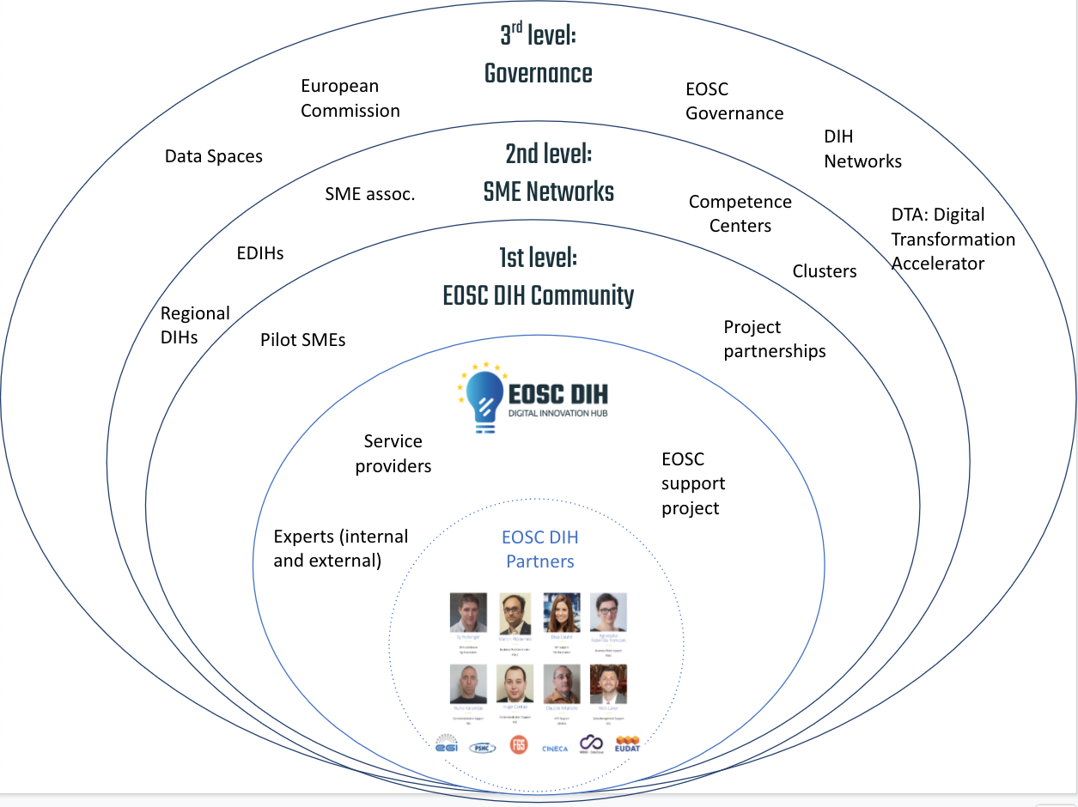

- Zero level: EOSC DIH. The people, entities and projects that allow the EOSC DIH to work. This core level includes the main EOSC DIH partners (mainly starting with those entities with effort in WP9 of the EOSC-hub project), other internal experts and service provider members. Will be expanded by those agreeing to the Terms of Reference.
- 1st level: Members of the community. Includes the running pilots, the experts offering services to the pilots and the partnerships that participate in the regular activities and meetings that the EOSC DIH organises.
- 2nd level: Potential partners. Includes the companies or entities that could participate by providing or consuming the services of the EOSC DIH.
- 3rd level: Decision making and networks. These include the policy making entities and DIH networks that support mechanisms for implementing the activities, existing and future.

- Community Members Rights and tasks
The Community members will have the following rights:
- Community members participating under pilots or partnerships will be included on the EOSC DIH website according to their category.
- Community members will be invited to participate in regular community meetings and actively participate in webinars, conferences and other activities.
According to the needs and project objectives, community members may receive invitations to participate in project proposals to obtain direct funding.

In order to maintain an active and engaged community, community partners will participate in the following activities and tasks:
- Community members will participate, to the extent possible, in the activities of their interest organised by the EOSC DIH such as webinars, conferences or workshops.
- Community members will contribute to the sharing of relevant external information for the community such as news and events.
- Community members will actively participate, to the extent possible, in the Community meetings that will take place regularly.

- Additional Roles
Description of some roles that individual DIH partners could represent as part of the DIH e.g. coordinator, DIH support, service specific rep, other DIH liaison, national/regional DIH rep, sector/domain expert in DIH.

Role | Description | Number of persons
Pilot Lead | Lead contact for managing in the pilot lifecycle from ensuring service provision to all documentation including website content, workplan and final reporting | 1 per pilot
Service expert | Specific service expert for supporting pilots or services part of the DIH catalogue | 1 per service
National DIH contacts | Serving as an interface with a specific national or regional DIH | 1 per country
Other DIH liaison | Serving as an interface with a specific national or regional DIH | 1 per DIH
Specific Support Project Representative | Serving as an interface with a specific support project | 1 per project

- Community sustainability
Keeping an engaged community in an organization such as a DIH is one of the main pillars for long-term sustainability. An engaged and active community maintains the spirit of the DIHs as real hubs for innovation and co-creation while remembering the management and technical members the real needs of the industry.

The EOSC DIH intended to create a space where multiple types of companies and stakeholders could live together with different levels of participation and engagement.

The community map previously described represents the companies, entities, projects, networks and associations that interact or influence the daily work of the EOSC DIH distributed in 4 levels: the EOSC DIH itself, the EOSC DIH community, the potential partners and the governance (decision makers and networks). For those levels of stakeholders, there are different phases to consider when creating a community and can be summarised as follows:

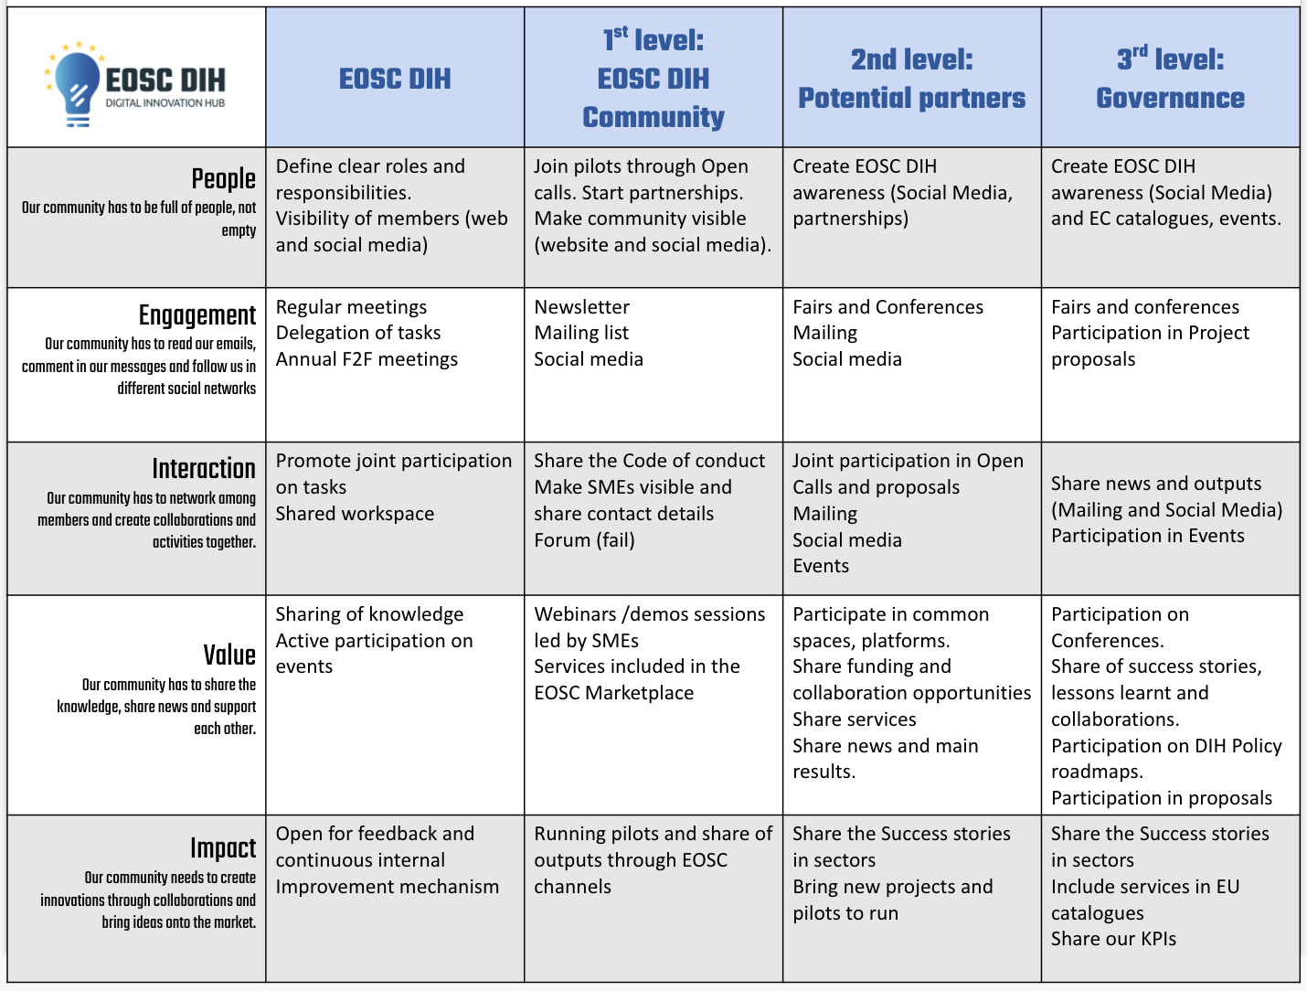
Fig.22: How to facilitate community dynamics table

To guarantee the active involvement of the members of the community in the EOSC DIH a Code of Conduct was created. It is expected that these rules would help companies to feel and perceive the EOSC DIH as a safe place for sharing the ideas, doubts and knowledge. The objective is to make people more empathetic, support members to actively listen to each other and to care about what others are saying; to help people to focus on positive interactions to generate positive energy, being nice, kind and caring to each other; to help to build relationships among ecosystem members. This code of conduct is public on the EOSC DIH website under the Community section and will be regularly shared among the EOSC DIH social media channels.

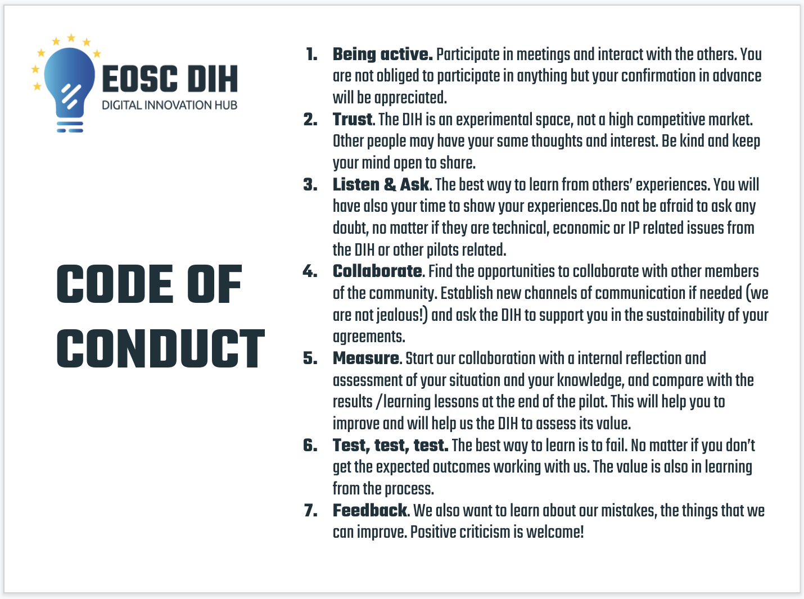
Fig.23: Code of conduct for the EOSC DIH

- Communication Channels
This table provides a summary of the internal and external communication channels available within the EOSC DIH.

Communication Channel | Reference / Link
EOSC DIH Mailing Lists | partners@eosc-dih.eu
Website | https://eosc-dih.eu/
Confluence | https://confluence.egi.eu/display/EOSCDIH/EOSC+DIH+Home
Slack | eoscdih.slack.com (restricted channels)
External Communication Channels | Reference Link
Twitter | https://twitter.com/eosc_dih?lang=en
LinkedIn | https://www.linkedin.com/company/eosc-digital-innovation-hub/
Email | business@eosc-dih.eu
Slack | eoscdih.slack.com (dedicated community channels only)

- Reports
An annual report will be produced by the EOSC DIH Partners to summarize the key activities carried out by the EOSC DIH.

Any deliverable produced via a relevant EC funded project shall be shared, where possible, with the Partners.

Community members will be offered to the opportunity to contribute where relevant.

- IPR
Any result of research, work, publication or invention that derives from the activities carried out within the scope of the EOSC DIH and susceptible to economic exploitation or may give rise to a request for ownership of industrial or intellectual property rights, must be notified to the signatory entities.

In each contract or project, issues related to the ownership of the results, their management, and the conditions of protection, development and exploitation associated in each case will be regulated. As a general rule, the management of protection and the transfer of research results will be carried out by the majority party in ownership.

- Evaluation
A survey will be conducted at least on an annual basis, ideally every six (6) months, in order to collect feedback from both the EOSC DIH partners as well as the community members to gauge the effectiveness as well as suggestions for improvement.

- Amendments
Any modification of the ToR will be made available to all Partners and community members.

The Partners agree to review this ToR, ideally once a year.

https://eosc-dih.eu/about-us/
eoscdih.slack.com

