

iSGTW Status Update
July, 2011

Subscriber numbers for iSGTW newsletter over the past 6 months, compared to the same time one year ago:

Feb ’10: 5,843 Feb ’11: 7,942
March ’10: 5,881 March ’11: 8,131
April ’10: 6,068 April ’11: 8,088
May ’10: 6,131 May ’11: 8,074
June ’10: 6,287 June ’11: 8,092
July ’10: 6,444 July ’11: 8,092

ISGTW content that appeared in June, 2011.

- 4 issues published:
6 July: http://www.isgtw.org/issues/6-july-2011
13 July: http://www.isgtw.org/issues/13-july-2011
20 July: http://www.isgtw.org/issues/20-july-2011
27 July: http://www.isgtw.org/issues/27-july-2011

- 4 ‘lead’ feature stories - those in the most prominent position on the front page and below the headline. 2 US lead, 2 EU lead.

- 8 ‘ordinary’ features (less prominently placed on the front page, and one of which, users have to scroll down to in order to read). 4 US and 4 EU. Lead features and regular features were balanced geographically.

- Links/Spotlights and Images/Visuals: 2 EU, 2 US.

- 2 features on grid computing, 2 on clouds, 2 on high-performance computing (supercomputing), 1 on volunteer computing and 1 on cyberinfrastructures,

- Features covering subject areas outside of parallel computing were a new particle discovery at Fermilab: neutral Xi-sub-b, challenges facing researchers in Asia Pacific, lattice Quantum Chromo Dynamics (QCD) and Graphical Processing Units (GPUs) with music.

- Visuals and spotlights were about our iSGTW reader survey, the Square Kilometer Array (SKA), Field-Programmable Gate Array chips (FPGAs), noise visualisation with high-performance computers, an international science visualization contest, Planet OSG: a new website that aggregates blogs from Open Science Grid and 3D chemistry computer games.

- Geographic coverage including features, visuals and spotlights came from Geneva, Chicago, Würzburg - Germany, Asia Pacific, New York, North Carolina – USA, Indiana – USA, Aubière – France, Vietnam, Edinburgh -Scotland, London, St Andrews – Scotland, San Diego – California, New Jersey – USA, Salt Lake City – USA and Illinois – USA.

- As we didn’t get as many responses as we originally hoped for our annual iSGTW reader survey, on the 6th July we published it again via a spotlight. Participants were also entered into a draw to win a prize - the opportunity to have a poster specially designed for a project of their choosing by e-Science Talk designer André-Pierre Olivier. Then, we posted the iSGTW survey poster competition again as a visual on 20th July 2011.

- The most popular page of the month was our story: Virtual atom smasher in LHC@Home 2.0. It received 2,085 unique users, 2,280 page views and an average of 6:28 minutes was spent on the page.

- ‘The evolution of words’ feature was the second most popular page (if you exclude our homepage) of the month with 1,424 unique visitors and 1,641 page views.

- The ‘Our 3D universe revealed’ visual from June last month was the third most popular page with 884 unique visitors and 981 page views. Last month this page was the second most popular page with over double the metrics, i.e. 1,983 unique visitors and 2,173 page views.

- The average time spent on iSGTW was 1.45 minutes, a rise compared to 1.14 minutes in June 2011. 44% of our traffic accessed our site through the Firefox browser which is a rise from last month’s 42%.

- This month we received a total 11,762 unique users compared to the previous month’s 19,205, a fall of 7,443. We also received 21,951 page views and 14,802 visits in July 2011. 72.17% of these were new visits. Last month, we received 31,953 page views and 23,352 visits. This is a drop of 10,002 page views and 8,550 visits respectively.
Since our relaunch in January 2011, page views have risen steadily each month apart from April, May and July.

- XenoMedia stated they would remove email bots from our newsletter subscriber list.

ISGTW Metrics:
All data from Xenomedia, Drupal: Open Publish & Googleanalytics unless otherwise noted.
Total Subscriptions in July 2011 remains the same at 8,092.
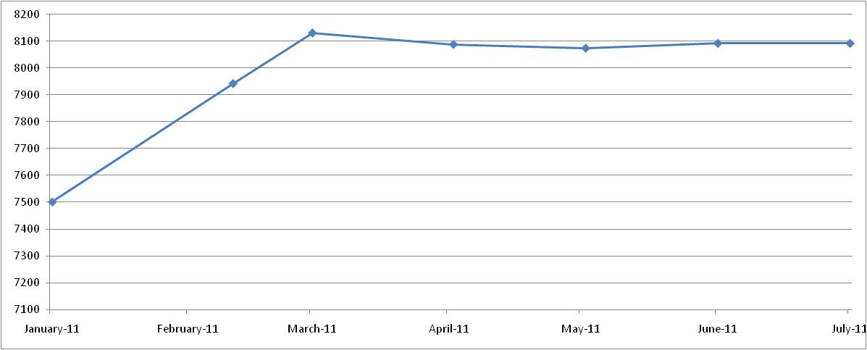
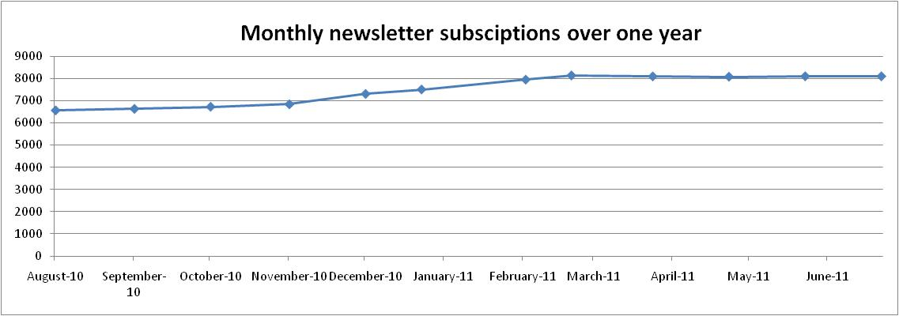
As of January 2011, above data is from Drupal: Open Publish due to relaunch of iSGTW.

Total number of pageviews for July 2011 is 21,951.
A ‘pageview’ is an instance of a page being fully loaded by a browser. Please note that in January 2008, we switched from Webalizer’s IP-based ‘sites’ and ‘visits’ to Googleanalytic’s cookie-based ‘Page Views’ and ‘Visitors,’ in order to get a more accurate picture of iSGTW’s website status.
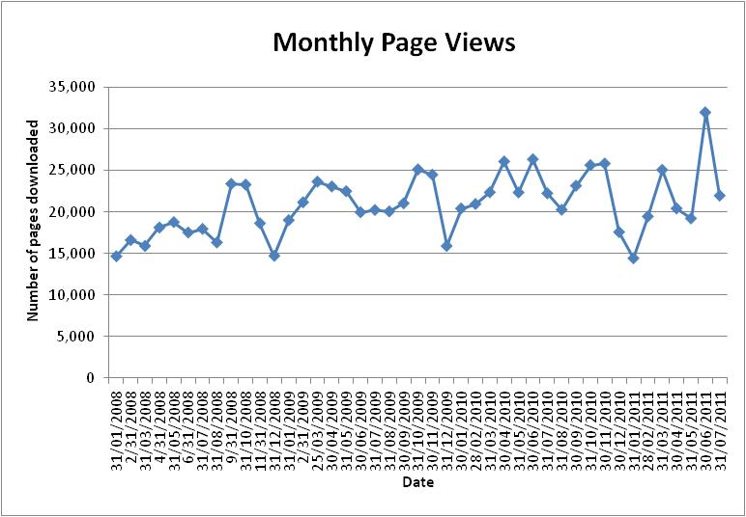

Total number of Absolute Unique Visitors for July 2011 is 11,762.
A ‘Unique Visitor’ is a construct designed to come as close as possible to defining the number of actual, distinct people who visited our website. Googleanalytics calls these ‘Absolutely Unique Visitors.’
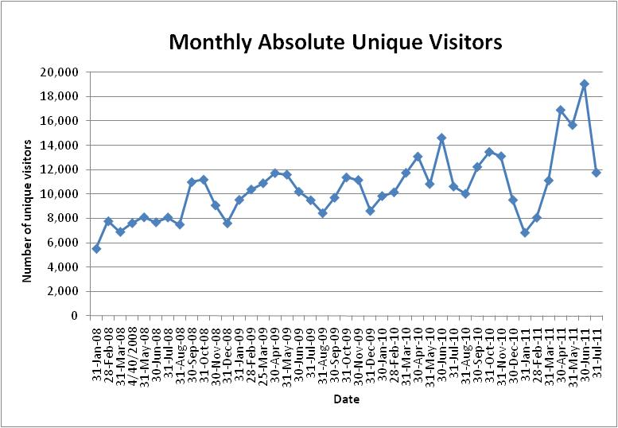
Traffic sources and social media

A breakdown of overall traffic shows that 34% of visits going to the isgtw.org domain were from direct traffic, down 3.5% from last month (June: 37.5%). Also, 43% of our web traffic were referred from other sites. 22% of traffic were from search engines.

Google was the second most important source of web traffic (21% of visits), up 9% from last month’s 12.35%. ISGTW received 10% of referrals from social bookmarking site stumbleupon.com (1,505 visits) and 10% of referrals from reddit.com (1,489 visits).

We continually promote iSGTW stories on Facebook (3 times a week) and Twitter (every day) to increase our web traffic referrals. We are monitoring this strategy over the coming months to see if we receive sustained additional traffic.

A ‘visit’ indicates the number of unique sessions initiated by our visitors. A ‘visitor session’ is a defined period of interaction between a visitor (both unique and untrackable visitor types) and a website. Google Analytics records a visitor as new when any page on iSGTW has been accessed for the first time by a web browser. The number of visits iSGTW receives is the most basic measure of how effectively we promote it.



