“NGI Services Site” for NGI A/R calculation

Problem statement
Currently it is not possible to generate NGI availability and reliability (A/R) statistics that only include “core” middleware services that are operated directly by the NGI, as typically these are hosted by different sites, and current A/R reports are per-site (i.e. only include services that are hosted by the same site in GOCDB terms). A “core” service is defined to be a middleware service that is used to access Resource Centre grid services. Examples of core services are FTS, top-BDII, VOMS, WMS and LB, etc.
An easy mechanism to circumvent the problem, is to register all NGI core middleware services in a single “NGI Services Site”. Note that core services can be operated by Resource Centres to support specific local projects. These core service instances are out of scope of this proposal. This proposal specifically applies to NGI services.
The proposed approach has the benefit that the existing infrastructure for monitoring and the computation of A/R reports can be used. It also allows the generation of NGI summarized availability statistics.
The proposed solution addresses Use Case 1 detailed in: https://wiki.egi.eu/wiki/POEM_and_ACE_requirements

STEP 1. New GOCDB “NGI Site”
A new “NGI site” is created in GOCDB. A possible naming scheme is: “NGI_<countrycode>_SERVICES”.
See an example in GOCDB: NGI_IT:
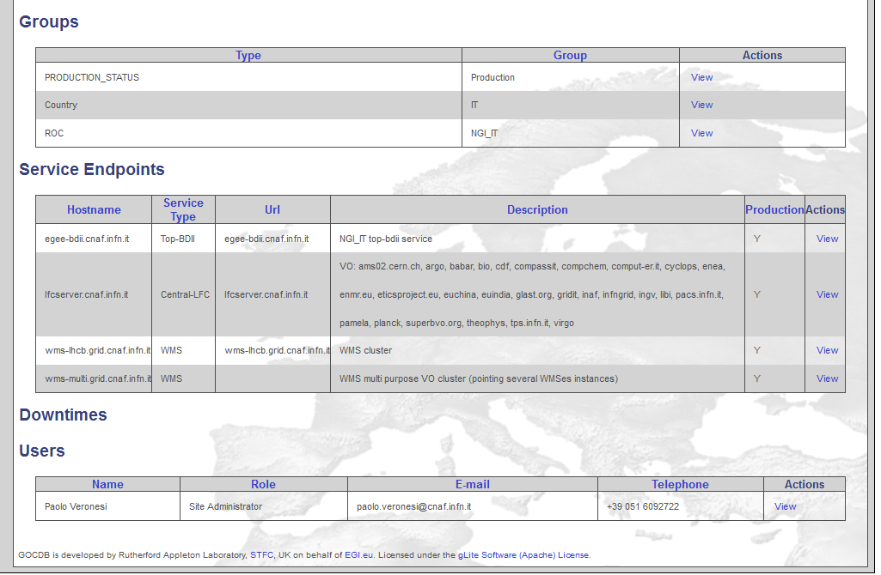

STEP 2: Add NGI Core services
The exact list of services that belong to a NGI site depend on which services are operated by the NGI. Examples of services are
- TOP BDII: egee-bdii.cnaf.infn.it – alias of 5 geographically distributed VMs
- LFC: lfcserver.cnaf.infn.it – alias of 2 geographically distributed physical instances
- WMS: wms-lhcb.grid.cnaf.infn.it – alias of n (n dynamically variable) geographically distributed physical instances for the LHCB VO
- WMS: wms-multi.grid.cnaf.infn.it – alias of n (n dynamically variable) geographically distributed physical instances for various regional VOs
Note 1. Only alias of distributed physical instances were added to the NGI_IT site. These are monitored in SAM. Within the cluster, not working instances are automatically removed from the aliases through Nagios, so by including the alias the A/R of the cluster is considered (not of the single instance). By including the aliases the A/R of the instances of a given service are OR-ed, for example down times of a single instance will not be reflected in the A/R of the alias.
Note 2. Physical (or VMs) individual service instances that are physically hosted by different GOCDB sites, were NOT REMOVED from their original hosting sites. These can be left in GOCDB, as they can coexist with the alias. Having the individual instances registered can be useful in order to have alarms for the physical instances (these notifications are important even if the outage of one instance does not mean and overall service outage).
Note 3. VOMS servers are currently not added. NGI has all the VOMS servers replicated in a master/slave configuration, this means:
- No alias available (to be investigated if it’s possible to have an alias for voms server, currently failover is handled on the client side)
- Web admin interface available only on the master instance
- Down of the master instance only affect users registration, proxies can still be created on the replica – need to understand if this is considered critical and should be reported in the NGI_IT site availability
So the VOMS instances even if replicated, are not totally functionally equivalent. Nevertheless, the VOMS severs can still be declared in the NGI Services site. Service flavour status can be computed by OR-ing the service endpoint status (as it is currently done for CEs, SEs etc.). The implication of this is that if VOMS 1 supports VO1 and VOMS 2 supports VO2, then if VO1 is DOWN and VO2 is UP, then:
- VOMS overall OPS Availability is 100%
- The availability experienced by VO1 is 0%
- The availability experienced by VO2 is 100%

STEP 3: Add Contact Information
The NGI Administrators staff was added as contacts for the NGI site.

STEP 4: Installation of site-BDII
In order to have the site monitored it is sufficient to create it in GOCDB , i.e. a site bdii IS NOT NEEDED for monitoring purposes but it was initially installed to have those service aliases published into the information system.
Now we are testing the NGI_IT site without the site bdii, monitoring and a/r calculation seem to work, but by doing so aliases are not published for the time being into the information systems.
If a site BDII is not installed and services/alias are published in other GOCDB sites, an inconsistency is introduced. The consequences of this inconsistencies were not investigated.

STATUS of NGI Grid Services in OPS tool web interfaces and PIs

GOCDB EndPoint
Site NGI_IT is available in the GOCDB programmatic interface:
https://goc.egi.eu/gocdbpi/public/?method=get_service_endpoint&sitename=NGI_IT

Example of top-BDII Status (ROC_OPERATORS profile)
https://mon-it.cnaf.infn.it/myegi/history/?facelist_values_regions=&facelist_values_Sites=&facelist_values_services=2448%2C&vo=37&profile=2&monitored=2&status=1&status=2&status=3&status=4&status=5&startdate=01-09-2011&enddate=

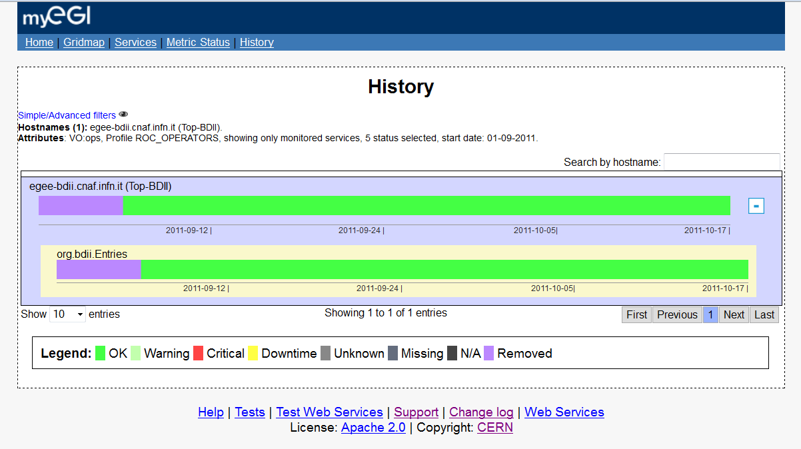

Example of WMS Status (ROC profile)
ROC profile gives the status history of various metrics: hr.srce.WMProxy-CertLifetime, org.nagios.GridFTP-Check, org.sam.WMS-JobSubmit.
https://mon-it.cnaf.infn.it/myegi/history/?facelist_values_regions=&facelist_values_Sites=&facelist_values_services=6545%2C&vo=37&profile=5&monitored=2&status=1&status=2&status=3&status=4&status=5&startdate=01-09-2011&enddate=

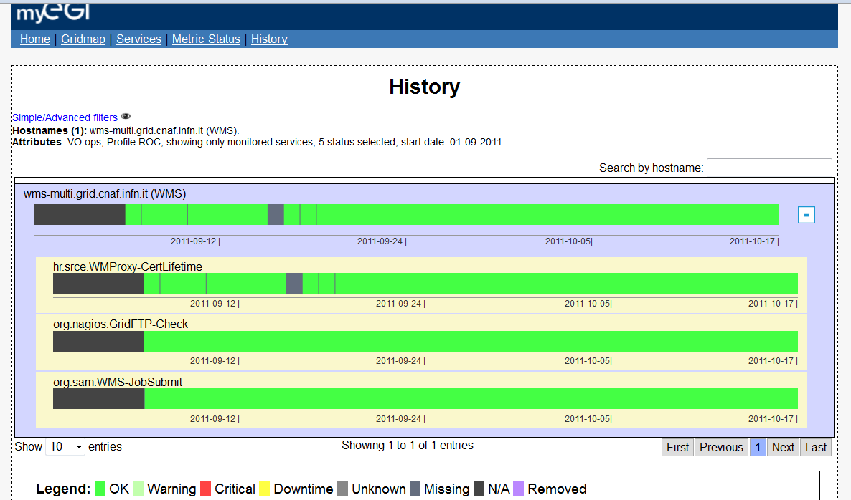

Availability plots (ROC_OPERATORS)
Availability seems to be correctly computed for single instances and aggregated according to the profile chosen: ROC_OPERATORS profile:
http://grid-monitoring.cern.ch/myegi/sa/?view=3&facelist_values_groups=&vo=37&profile=2&site=114164&graph=1&startdate=&enddate=
The ROC_OPERATORS profile (http://grid-monitoring.cern.ch/myegi/sam-pi/metrics_in_profiles?vo_name=ops&profile_name=ROC_OPERATORS) was chosen in order to include all the NGI core services. Currently resource centre A/R reports only include a subset of services (site-BDII, CE and SE). ROC_OPERATORS includes also LFC and FTS, WMS and VOMS metrics.
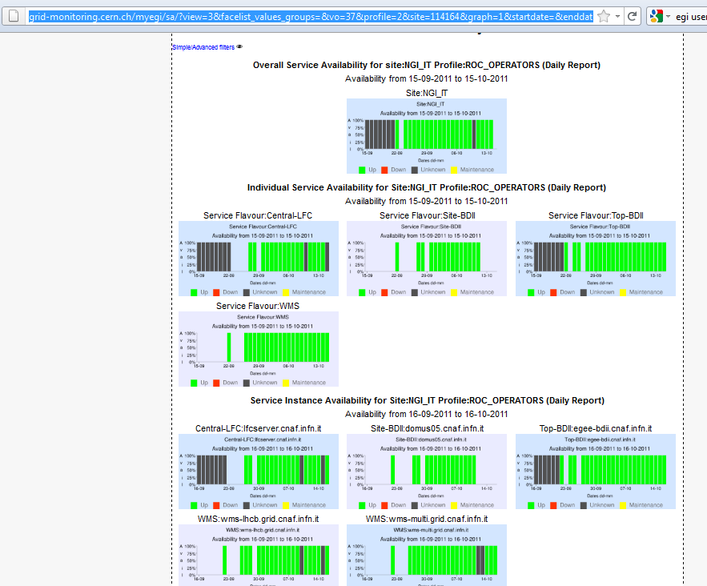

Other profiles

ROC_CRITICAL (only site-BDII)
http://grid-monitoring.cern.ch/myegi/sa/?view=3&facelist_values_groups=&vo=37&profile=7&site=114164&graph=1&startdate=&enddate=
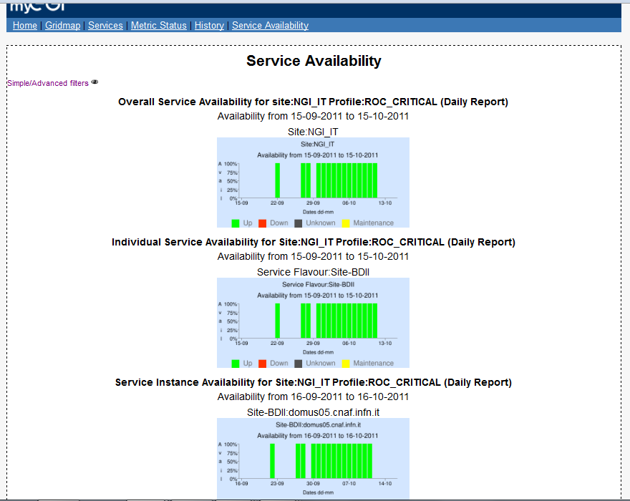

Availability in myEGI PI
The NGI_IT site available and reliability raw data are available in the myEGI PI – as for all standard GOCDB sites - in:
http://grid-monitoring.cern.ch/myegi/sam-pi/group_availability_in_profile?vo_name=ops&profile_name=ROC_OPERATORS&start_time=2011-10-01T00:00:00Z&end_time=2011-10-02T00:00:00Z&type=HOURLY&group_type=Site
The finest available granularity is 1 hour .

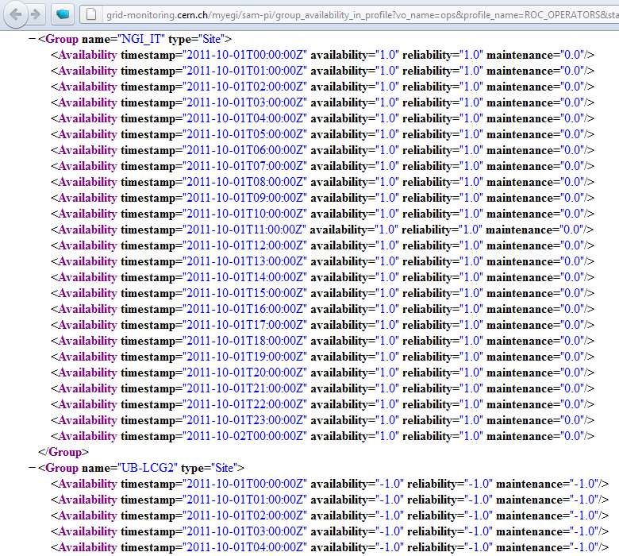

NGI Site in Monthly A/R Statistics
The NGI_IT site appears in September status reports – Note: It was created on the 22nd of Sept.

Operations Dashboard and Alarms Workflow
The NGI_IT site appears in the ops portal dashboard and we expect the same behaviour of all other sites for what concerns alarms workflow. No failures during the considered period (from 22nd of Sept till now)

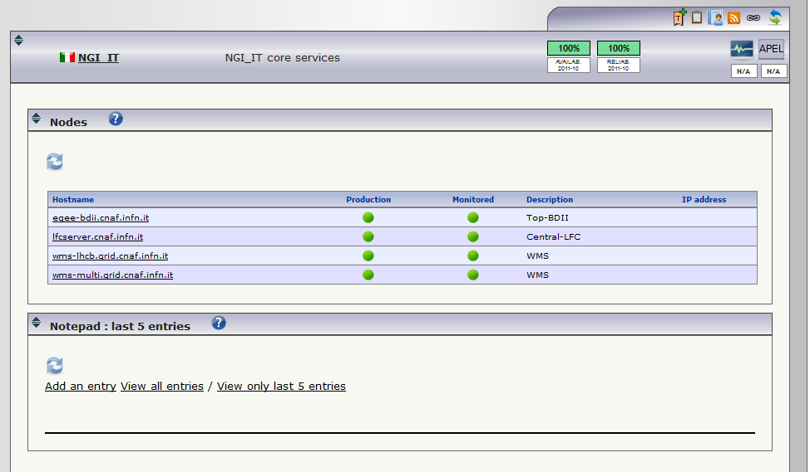
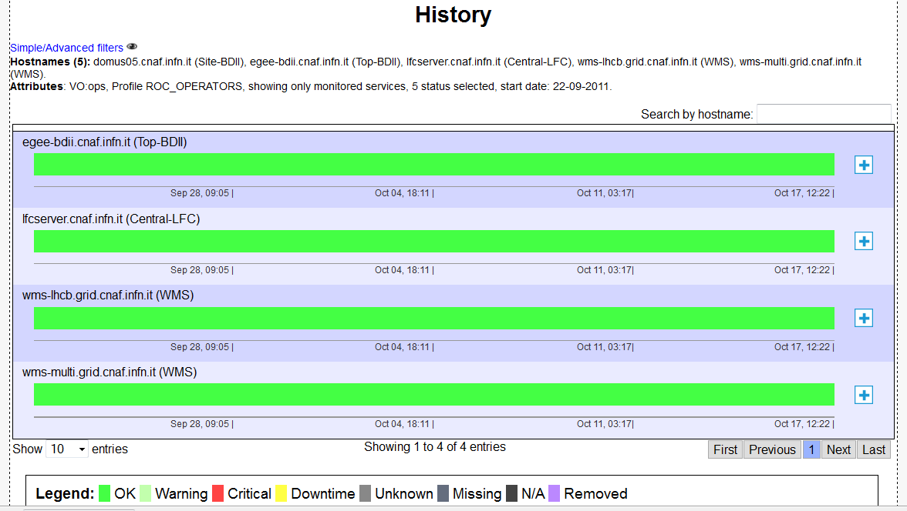

Conclusions
- The mechanism of aggregating NGI core services using GOCDB though the creation of a dedicated sites seems to work for what concerns monitoring and a/r calculation.
- NGI_IT tested it adding only aliases to distributed instances of the considered services (top bdii, lfc server, wms ). Since not working instances are automatically removed from the aliases, this has the effect of ORing the test results of the physical instances. Downs of physical instances do not affect the a/r of aliases.
- N different instances of non-equivalent end-points (such as VOMS) of the same service type can be part of NGI_X_SERVICES, but the OPS A/R figures won’t reflect the A/R experienced by VOs if one of the end-points is faulty (assuming the VO is supported by a subset of the end-points in the pool).
- NGI_X_SERVICES physical end-points can still be part of physical sites since it can be useful to have alarms on their status for the site admins.
- In order to have the aliases published in the information system a site bdii must be installed. But this is not mandatory for the site to appear in monitoring tools).
- ROC_OPERATORS profile can be used to get per service flavour and per NGI_X_SERVICES site A/R figures. Data can be extracted from MyEGI to produce reports.

