The New NA2:
Engaging with new user communities
Table of Contents
1 Abstract 1
2 User Community Engagement 2
2.1 Engagement Models 2
2.2 Layered Service Infrastructure 3
2.3 Community Wide Engagement 4
2.4 Knowledge Base/Asset register 5
3 Virtual Teams 7
3.1 What are Virtual Teams? 7
3.2 Request for Engagement 8
3.3 Processes for Establishing a Virtual Team 8
3.4 Processes for Running the Virtual Teams 9
4 Example Use Case: Humanities 10
5 Next Steps 11
5.1 Timeline 11
5.2 Activity 11
6 Summary 13

Abstract
The purpose of this document is to describe how the new structures being defined for the revised NA2 workpackage within the updated Description of Work will work. The purpose of the restructuring is a framework that can significantly improve the efficiency and flexibility of the interaction between the NGIs, EGI.eu and other organisations to achieve common goals. These teams can be used to enable the development of a strategy for the long-term evolution of EGI, or to significant increase both the diversity and quantity of users and communities exploiting the infrastructure for world class research. The application of the framework is limited only by the scope and imagination of the NGIs to commit resources to any particular goal.

User Community Engagement

Engagement Models
EGI’s underlying route to improving its sustainability is to grow its user base, both in terms of the numbers of unique users but also in terms of supporting more diverse communities. To do this requires an innovation strategy that operates on two axis: firstly to deliver improved usage of the existing infrastructure and secondly to deliver new services that help EGI diversify its user base.

To facilitate this engagement, through the merged NA2 and NA3 activity within EGI-InSPIRE a number of engagement models have been defined. At a high level these are derived from the following 4-cell matrix which covers these two axis:

 | Serving Current Users | Serving New Users
with Current Services | Current EGI operations, these will be continually improved | Integrate new applications to support new users with the existing EGI Services. (Model A)
with New Services | Expand the current services to meet the needs of current users. (Model B) | Support new services needed by new user communities. (Model C)

Whilst existing services will be improved the focus of these new activities is on increasing usage. The following models describe how this will be achieved:
- Model A aims to enable applications on EGI using the existing middleware services and existing high level frameworks and tools (for example job submission frameworks, workflow systems).
- Model B includes application integration activities that build on existing middleware and community software services, but at the same time require significant extension to these in order to succeed. These activities will require specialist knowledge that may not exist within the NGIs but could exist in technology projects (for example ScalaLife, SCI-BUS, EDGI) or within user communities (for example Life Sciences Grid Community, Earth Sciences Community).
- While both models A and B build on the existing operational framework of EGI (by using the existing middleware), model C integrates a completely new set of middleware services within the existing operational services in order to support new high-level applications and use cases.

It should be recognised that interaction models A, B and C illustrated above represent a spectrum of activity that may be undertaken by EGI. Depending on the nature of the user community being addressed, one or more of these models will be used as a basis for the engagement project. Within a single community (e.g. humanities) there can be numerous applications and groups and these may require different support models from EGI. It is anticipated that over time a library of successful and repeatable templates will be collected as well as an equally valuable track record of success stories promoting the achievements of the engagement projects.

One of the key decision criteria for initiating (and continuing) a user engagement project will be the potential for producing a compelling research-related success story describing the outcome that will have been achieved as a result of this work.

Layered Service Infrastructure
A sustainable service ecosystem needs to recognise that different stakeholders will need to take responsibility for three important aspects around each component used in a distributed computing environment:
- The development and maintenance of the software service
- The validated integration of the software into its deployment environment
- The deployment and operation of the individual software instances

This is recognised in the figure below where for different research communities there are:
- Services common to all (e.g. infrastructure services such as accounting)
- Services common to some research communities (e.g. job submission)
- Services specific to a single research community (e.g. workload management system)
- Services specific to a single user (e.g. workflow engine)
Note - Although these might be separate service instances run by different organisations for different user communities, they may use software coming from a common provider.

The three models (A, B & C) identified earlier contribute to this service layer as follows:

Model A): Builds on top of the common service infrastructure to provide a customised solution (through application porting and integration with portals or workflow systems) that meets the need of a specific new user community.

Model B): Introduces incremental changes to the existing services to meet the needs of the current user communities.

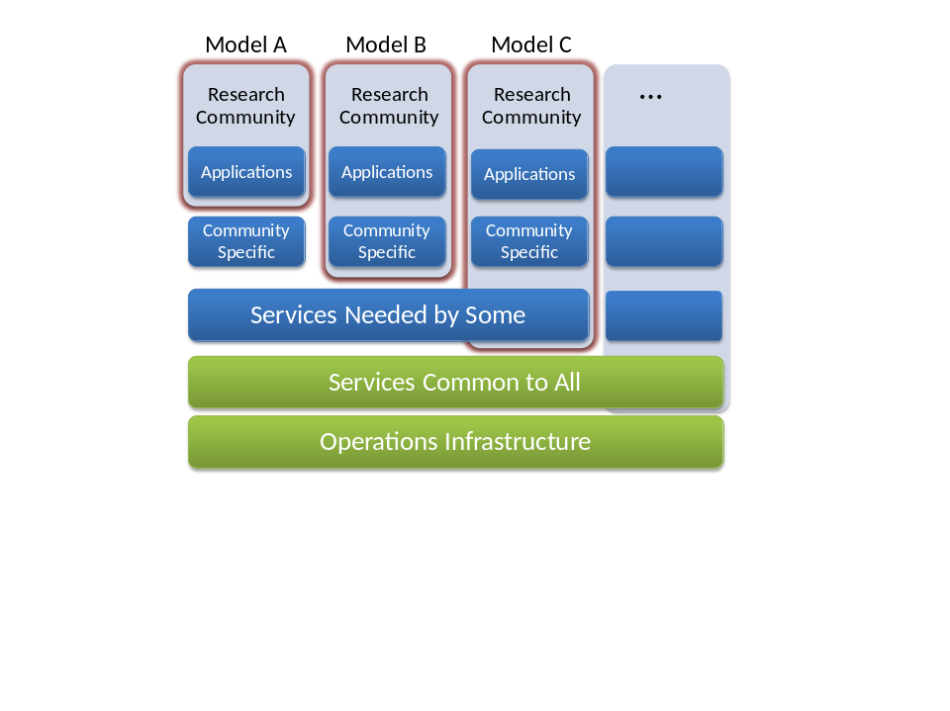Model C): Reuses the current operational infrastructure by integrating new services supporting different data analysis models to enable new user communities to use distributed computing infrastructures. These services may be deployed individually on sites that are willing to do so, or in the future within virtual machine appliances deployed on a virtualised infrastructure offered by an NGI.

Community Wide Engagement
EGI needs to use the three models in a mixed way in order to successfully engage with different types of communities. Engagement activities targeting e.g. specific communities and/or applications need to be initiated and run by EGI. It is foreseen that different members of EGI want to participate in such targeted activities with different intensity and with unique skills. The skills needed for EGI to successfully engage as a community exist in many different organisations within EGI-InSPIRE and in the broader EGI ecosystem. The location of these skills need to be established within EGI (i.e. EGI.eu, the NGIs, collaborating projects, etc.) and made available to meet specific well-defined needs that are aligned to the strategic goals of the EGI community. This is where the expertise and knowledge of the NGI Coordinator is vital. It is their role to evaluate each request for NGI skills and time against the priorities and interests of the NGI.

The individuals with these skills will be brought together in Virtual Teams. Virtual Teams provide a flexible and dynamic means to rapidly bring together certain members of the community for a well defined series of tasks to meet a specific need that needs to be achieved in a relatively short period of time (on the order of weeks or months) before being disbanded. The focus of these virtual teams will be to either directly increase the number of EGI users (e.g. through integrating a new application) or indirectly (e.g. by raising the profile of EGI and an NGI through a NGI hosted event for its users).

The projects that these virtual teams will be established to complete will vary, and it is clear that not every NGI will have the appropriately skilled staff available at all times to participate in every virtual team and thus will be unable to respond to every task.

Typical requests that are expected to be made through the NGI Coordinator for the NGI to participate in Virtual Teams are:
Task | Request to NGI and collaborators | Output
Identification of applications from community X | To engage with their contacts in community X and identify applications that are widely used within the community and could benefit from the integration with EGI. | List of applications with expected impact of integrating and supporting them in EGI. (A business case for application integration.)
Demonstrator for user community X | Staff to engage with the new user community in integrating and setting up their application and providing a portal and workflows on EGI resources. | A working documented demonstrator that can be handed over to the production infrastructure for wider deployment AND/OR can be further developed in a new projects.
Topical Community Workshop | To provide a venue, logistical staff, catering and publicity around a community event for up to 75 people. To proactively promote the event. | A successful well attended event takes place. Further clear input is acquired for new services and resources.
Policy Survey | To provide the data requested by the survey to help establish a community view of an issue. | Report to EGI Council
New Requirement | Related user stories providing clarification of the requirement and offers to contribute to the design document. | Design Document that can be contributed to a technology provider for implementation.
Produce Annual Report | Provide detailed input relating to individual country - e.g. Grid-related research use cases for central marketing material | Printed Annual Report
Strategy Document | To provide targeted input to a strategy document corresponding to the NGIs area of expertise – e.g. user group or policy area | Document endorsed by PMB

Knowledge Base/Asset register
A key factor in bringing new user communities into EGI will be to successfully marshal the distributed assets (e.g. technical expertise, software, resources) that exist within EGI to meet their needs. The NGI Coordinators are critical in not only accessing these assets but also in knowing of their existence. The training marketplace and application database are two examples of how information about the community’s assets are currently collected together and made available for all. Expanding our knowledge base to include information about the assets within the NGIs and collaborating projects (i.e. a service portfolio) will help us to understand what as a community we are capable of doing in the short, medium and longer term.

The research groups or communities that are interested in becoming part of EGI also hold critical information. Gathering this information will come from many mechanisms:
- EGI.eu discussions with ESFRI projects
- NGI discussions with new communities
- NGI discussions with existing and heavy user communities
- Polls and surveys
- Sessions at events, both EGI events and user community events
- Booths at key community events
- Focus groups
- …

The initial request for participation from a user community either comes directly from the user community or more likely from an NGI or EGI.eu initiated contact needs to contain structured information relating to:
- Requesting group
- Research area
- Specific tools
- Middleware
- …

The request will be prioritised within EGI.eu against the community’s already agreed strategic priorities. Reporting the contacts (through the NGI Coordinators) that NGIs have within potential new user communities will allow connections to be made between research activities taking place across different NGIs and to feed these connections back to the NGIs concerned.

If the request for engagement with the new user community is found to be aligned with the community’s priorities, a call will be issued for a virtual team to be established from within the EGI community to address the issue.

Virtual Teams

What are Virtual Teams?
Virtual teams are groups of individuals spread across different organisations that are brought together for typically small scale projects that cut across existing organisational structures within EGI. For instance a virtual team could have members from NGIs, collaborating projects and one or more of the specialist NA2 tasks:
- M & C: Marketing and Communications (TNA2.2)
- SPPS: Strategy, Planning and Policy Support. (TNA2.3)
- CO: Community Outreach (TNA2.4)
- TONC: Technical Outreach for New Communities (TNA2.5)
The virtual teams structure provides a flexible method to draw together expertise across the community for any goal. The virtual team is not a new model and has been used frequently in the past to generate ad hoc task forces for particular issues. The difference now is that the establishment and running of the virtual team is now structured enabling NGIs to make a clear decision as to if they should participate or not in the particular activity.

A specific motivation behind virtual teams is increase the number of new users and new user communities for the benefit of NGIs, VRCs and the EGI community as a whole. This may take place explicitly through the three models defined earlier:
Virtual teams assigned to interventions | M & C | SPPS | CO | TONC | NGI participants
Model A - new users, current services | Preparation and distribution of promotional material about current services | Policy documents for a new VRC | Attend key event for new community | Refinement to a current service | Training sessions for service targeted at new community
Model B- current users, new services | Updates to existing material for current community | Updates to existing MoU or SLA | Host technical workshops to develop new service | Ensure that new service is of production-grade quality | Launch and promote new services across existing community
Model C - new users, new services | Promote EGI benefits to a new community | Initiate and develop policy elements relating to groups and projects relating to this community | Run workshops, attend domain-specific events, coordinate involvement at EGI forums | Identify specific applications and services needed by this community and develop them | Bring key players from within a specific community into these activities

More broadly virtual teams provide an effective way to collaborate that can be used for other projects that will implicitly help the development of the EGI community. For instance:
- Annual report that satisfies the funders of the NGIs that their funds are well invested
- Well attended, financially successful events
- High quality materials that promote the project to current or new users
- Publicity in mainstream and trade media that promotes the goals of the project to the general public and funders
- High visibility at community and user focused events
- High impact of the website and social media channels

Request for Engagement
Before a request for engagement is sent out to the NGI Coordinators and other parties within the EGI ecosystem, a project initiation document will be prepared by TNA2.3 that:
- Provides a clear description of the resources being requested
- Identifies the value to EGI and the NGIs as to why the request should be undertaken
- The deadline for engagement
- The expected duration and effort required
- The expected final and any intermediate outputs (with dates)

If NGIs and other parties in the EGI ecosystem who appear to have relevant skills (according to the EGI asset database) choose not to respond to the request for engagement with required resources, then the project initiation document has not been supported by the community and no further action is taken. The document and the lack of response is recorded for later reference.

It is the NGI Coordinators that will receive the project initiation document. They will have to make the assessment and respond within the defined time period as to if this is an activity that the NGI is willing to contribute to. If they feel this activity is aligned with their national priorities and that they have resources available, then they will need to identify how the NGI’s assets can contribute to the project and report these as being available as part of the virtual team.

Possible Implementation: The project initiation request is recorded in a dedicated RT queue. The project initiation document developed as a wiki page so that it can be developed collaboratively and then fixed when circulated to request resources. The comment mechanism in the RT queue can be used for partners to record their willingness (or not) to contribute to the activity. The comment feature in the wiki can be used to record comments on the project initiation document directly.

Processes for Establishing a Virtual Team
The Virtual Team Leader will be drawn from the resources that are contributed to be part of the virtual team. They may reside in the NGI, EGI.eu or some other organisation. The organisation contributing the virtual team leader must recognise the time that such leadership positions require and ensure this is provided for. Likewise, the organisations contributing members to the virtual team must also recognise the authority of the virtual team leader to direct their staff within the bounds defined in the project initiation document. For the purposes of the virtual team’s project the virtual team leader reports to EGI.eu (acting on behalf of the EGI community) and issues relating to the virtual team and its progress should be escalated to EGI.eu (Director or their designate) as required.

The project initiation document forms the basis of the project plan that the virtual team will undertake and will be regularly reviewed (see below). This virtual team structure is designed to respond to a specific community need in a relatively short period of time. It is possible that as a result of this collaboration a longer-term programme of work or issue is identified that could be established as a separate EC funded project. However, the virtual team itself will not be allowed to extend itself beyond its original scope - these individual projects need to have a clear start, middle and end. If further work beyond the original scope of the project is identified then this must be encapsulated in a new project initiation document that goes out to the community to establish a new virtual team.

Possible Implementation: Space can be set up on the wiki for the virtual team. Email lists can be established. Trackers need to be established to allow the virtual teams to monitor the progress of work items.

Processes for Running the Virtual Teams
The NA2 task leaders and NA2 activity manager will meet at the start of each week to coordinate the internal EGI.eu teams and the progress of the virtual teams running within the community. Many of which will involve contributions from the different EGI.eu teams that will need to be coordinated effectively. To support this weekly review, each virtual team leader will provide a short emailed report (due Friday 17:00) containing:
- Work achieved that week
- Work planned for next week
- Progress against the goals in the project plan
- Issues that the virtual team leader needs help with (e.g. non-responsive partners, more resources, support from EGI.eu teams, etc.)

Monthly, the progress of the virtual team against the project plan will be reviewed and an assessment made as to if the project is on track, has completed, is making no or insufficient progress. Depending on the result of this assessment further action can take place - request for more resources, refinement of the project goals, or shutdown of the activity. This review will be undertaken through a telecon with the virtual team leaders and the NA2 task leaders. Feedback will be captured from each project and reviewed to learn lessons as to how the processes can be improved. The progress of each virtual team will be reported in the NA2 section of the quarterly report.

Each virtual team leader will be assigned a ‘buddy’ within EGI.eu (a contact in the NA2 teams appropriate to their activity) who will provide an identified sponsor that they can contact directly to escalate issues.

Possible Implementation: Collaborative environment based around telecons, wikis, emails, etc.

Example Use Case: Humanities
It is decided that engagement with the humanities community is to be a goal across EGI - how can we get this community using EGI resources? From such a goal a series of actions would take place.

- Establishing Contact: Message to all NGI coordinators - what research groups have you had discussions with inside your NGIs in the humanities area? What issues are they reporting in using the current infrastructure? What services would they like to see deployed? Similar question directed at a European level by EGI.eu. Result: List of people to invite to a workshop and an idea as to the key issues that need to be addressed.
- Workshop: Establish a virtual team to host a ‘Humanities in EGI’ workshop. Bringing together a program committee, marketing, communication, event support, community outreach from EGI.eu and the NGI hosting the workshop. Result: A workshop with active participation from the NGI and EGI.eu provided contacts.
- Application Porting: At the workshop an application was identified that could be ported onto the current infrastructure. A virtual team is defined to port the application, to demonstrate that it works on a VO established across a few participating NGIs, and to package up access to the application through a portal that is customised with the workflow needed by the users of this humanities application. Result: The application running on EGI resources that can now be easily deployed on other sites which new users from this particular humanity community can easily access through the portal.
- Service Environment: The workshop also identified a web service that need to perform a complex language analysis over text based data sets - both of which are under active development. A virtual team is established to package the web service and data into a virtual machine image that can be deployed within EGI on the NGIs offering cloud infrastructure. Training is provided to technical experts in the humanities so that they will be able to build new virtual images as their software and data develops. Result: A new user community is able to flexibly use the NGI cloud resources within EGI to perform large scale data analysis.
- Exploitation: Given the success with these two areas of the humanities community, a virtual team is established to develop a marketing and communication plan around to undertake outreach to the humanities community at their events about the new capabilities being offered by EGI and the NGIs to their communities. Result: Knowledge of these two demonstrators spreads promoting greater uptake of EGI resources.

Next Steps

Timeline
The timeline for the remaining time of PY2 is described below:
Date | Activity
October 2011 | Revised DoW, supporting documentation and initial implementation plan (this document)
1st November 2011 | New DoW starts operation
4th November 2011 | PMB endorsement of the initial implementation plan
9th or 11th November 2011 | NGI Coordinator’s Kickoff meeting in Amsterdam
8th December 2011 | Presentation of current activity to the EGI Council
January 2012 | NGI Coordinator’s Workshop in Amsterdam
8th March 2012 | EGI Strategy submitted to EGI Council
29th March 2012 | EGI Council meeting
End of April 2012 | Strategy deliverable submitted to EC
Second half of June 2012 | EC Review

Activity
The NGI Coordinators Kick-Off meeting in November 2011 (provisionally one day) will provide the opportunity to disseminate to the NGI Coordinators and to other interested members of the project the scope of the changes in NA2 & NA3 and how they are expected to work - as described in this document. It will provide an opportunity to talk through the processes and the expected mode of operation. From this meeting we expect the first ‘projects’ to emerge and for project initiation documents to be developed around three key areas:
- Engagement with ESFRI communities (Model A & C)
- Vertical integration of applications for specific communities (Model A)
- NGI Input into EGI strategy documents

The remainder of the year will enable projects around these and other areas to become established and progress to be reported back to the EGI Council at its December meeting.

In January 2012, an NGI Coordinator’s workshop will be scheduled that will provide an opportunity for the various virtual teams to meet and share experiences. Two natural groupings are foreseen:
- User communities: A track allowing the different virtual teams working with new communities to come together.
- Long-term Strategy: A track for the various virtual teams working on developing long-term strategies for EGI’s sustainability to meet and discuss common issues. These groups are seen as the main source of material that will enter into the strategy documents to be delivered by EGI-InSPIRE in April 2012.

The EGI Community Forum will provide an opportunity for the results from the various virtual teams to be publicised to the whole community. Formally, the results from the strategic development studies will be presented to the EGI Council for endorsement.

Summary
The establishment of the virtual teams structures described in this paper takes the ad hoc task forces and working groups used within the community to a new level where they can play a vital strategic role within the EGI community. Through the NGI Coordinators there is now a defined point of contact to allocate resources to these groups that is aligned to the strategic priorities of the individual NGI, and the role they see themselves playing within EGI. Once established these virtual teams are integrated into a lightweight management and monitoring progress to help support the delivery of these community goals through any additional support they may need.

